

Role Description: Duty Manager (Facilities Management and Bookings)
- Contract Type: Permanent, 16 hours Annualised
- Hours: Flexible rota based on an annualised contract. Shifts are distributed to ensure continuous administrative and operational coverage across the week, Salary: £14.80 per hour (£30,784 pro rata)
- Reporting To: Centre Manager
About the Role
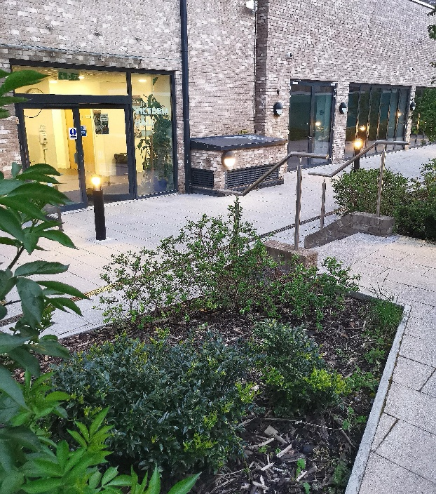
As part of our lean team with a big community mission, you will play a vital supporting role in the day-to-day running of our busy community and commercial dry-hire venue at Victoria Hall Harrow (VHH).
Rather than separating administration from physical facility management, our Duty Managers are trained to handle both. Whether you are overseeing a community event in the main hall or processing invoices at the reception desk, you ensure the venue always runs smoothly and professionally. You will be directly supported and mentored by the Centre Manager.
Key Responsibilities
- Multi-Skilled Booking & Front Desk Administration
- Provide continuous administrative cover during your rostered shifts, serving as a primary point of contact for VHH’s general inbox and phone line, and proactively triaging basic booking enquiries.
- Collaborate with the Centre Manager to process incoming bookings. Using Lemon Booking system, you will check availability, progress reservations and ensure invoices are processed efficiently so no administrative bottlenecks occur during operating hours.
- Conduct seamless shift handovers with other Duty Managers, ensuring all administrative tasks and communications with guests are clearly logged for the next person on duty.
- Complete scheduled quarterly check-ins with regular guests and members to understand their experience and help them maximise the value of their bookings.
- Anticipate guest needs before they arise using relevant information collected about guests to enhance and personalise their experience.
2. Facility & Duty Management
- Act as a welcoming, authoritative point of contact for guests using the building during your shifts.
- Conduct tours for prospective guests, highlighting benefits relevant to their needs.
- Oversee the physical space of the centre, ensuring halls and other spaces are set up safely and restored by departing hirers.
- Assist the Centre Manager with daily facility checks, maintaining strict oversight of building resources, hygiene room standards, and minor maintenance logging.
- Manage access for external contractors and vendors, ensuring they adhere strictly to the venue's health, safety, and delivery protocols.
- Conduct health and safety walkthroughs of the building to identify and address issues, escalating recurring concerns to your manager or the relevant team members.
- Know and explain VHH’s procedures, and keep members informed about building issues by email, phone, or in person.
- Manage the energy in the building ensuring music levels and activities are appropriate to the occasion.
- Liaise with in-building, third party cleaning companies to ensure space is kept up to standards.
- Track, audit, and distribute parking fobs collected and distributed. Manage fob stock and request new inventory as needed.
- Create incident reports as necessary, respond appropriately, escalate any medical emergency (injury or illness), and respond to instructions from Leadership regarding emergency situations or security alerts.
Essential Criteria
- Flexible Availability: Able to work a flexible annualised-hours rota, with shifts scheduled across weekdays, evenings, and weekends to support consistent administrative and operational cover.
- Reliability & Presence: High level of enthusiasm, punctuality, and the confidence to uphold venue rules (such as departure times, dry-hire terms and cleaning standards) with our guests.
- Team Fit: Excited to work collaboratively in a small, fast-paced charity team, with a proactive attitude - ready to listen, ask questions, and take on feedback.
- Cross-Functional Flexibility: The ability to seamlessly switch between desk-based administrative tasks and physical operational tasks throughout a single shift.
How to Apply
The deadline for applications is 18th of July. Submit a cover letter/statement of no more than 500 words, outlining:
1. Why you would like to join us.
2. Why you are a good fit for the role, and what skills and experience you will bring to the role and the charity.
Also send us something to share your previous professional and other experiences. This could be your CV, a link to your LinkedIn page, or you can write it up in any other format that you choose.
Send it to our CEO troy@victoria-hall.org who will acknowledge receipt, and then will be back in touch after the closing date. Troy will review the applications, and will then invite those who are successful for an interview.
The interview will be fairly informal, and the main questions will be sent in advance. This is an opportunity for us to get to know you better, and for you to learn more about us. It will be as relaxed as possible, and conversational. There will be no questions designed to trip you up.

