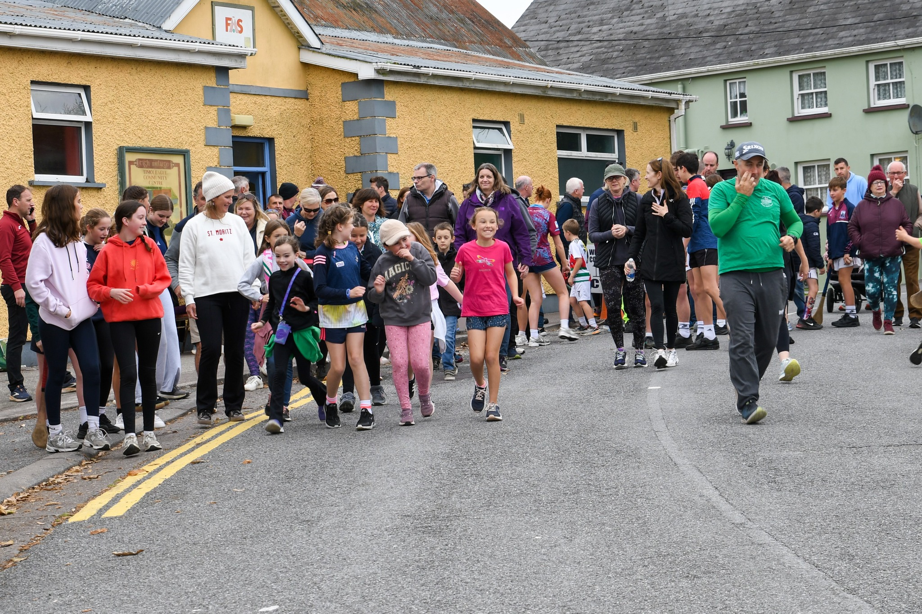

TIMOLEAGUE COMMUNITY CENTRE
PRICING 2026

ROOM | DURATION | COST
Main Hall | 1 hour | €20.00
Main Hall | Full day | €60.00
Room above Playschool | 1 hour | €20.00
Room above Playschool | Full day | €60.00
Parties (with use of kitchen) | Three hours | €60.00
Camps | Weekly hire | €250.00
Fitness Classes | 1 hour | €20.00

THE FEE WILL BE AN ADDITIONAL €10 PER HOUR AFTER THE FIRST HOUR

Bouncing Castle Providers must be registered with the Irish Inflatable Hirers Federation (IIFC)

Further information, please contact:

Email: secretarytimoleaguecommunity@gmail.com
Mobile: 086 8375555 or 086 1236360
https://timoleague.net

