Shirley Community Library —
Combined Risk Assessment & Management Plan
- Managed by: Play Place Innov8 CIC
- Prepared for: Play Place / Clarion Housing Group / Hirers / Partners
- Prepared by: Chris Hennis, Business Director
- Date: 16th October 2025
- Next review date: 12 months from issue or earlier after any significant change, incident or change of use.

Executive summary
This document combines information about Shirley Community Library (location, layout and activities) with legal duties and HSE best-practice guidance to provide a practical, auditable Risk Assessment and Management Plan for the center, its staff, visiting partners and hirers. It follows the HSE five-step approach to risk assessment and HSE guidance for events and venue management.

1. Scope and purpose
This Risk Assessment & Management Plan covers:
- Normal daily activity and regular programmed sessions (library, classes, community café, youth clubs etc).
- One-off hires and community events carried out on the premises.
- Build, set-up and breakdown activities associated with events.
It is intended for Play Place staff, Croydon Council (as landlord), external hirers, volunteers and contractors using or responsible for the site.

2. Responsibilities & governance
- Croydon (Pre-lease) / Play Place (Post-lease):
  - Maintain structure, main utilities (gas/electric fixed wiring), fixed fire systems where the license places responsibility.
  - Provide evidence of statutory inspections (gas, electrical periodic testing, fixed fire alarm/exit lighting if in landlord scope).
- Play Place (Managing Partner / Occupier):
  - Day-to-day H&S management, site risk assessments, emergency procedures, staff & volunteer training, contractor control.
  - Keep records of inspections, training, and incidents.
- Hirer / External Partner:
  - Provide their own activity-specific risk assessment and insurance.
  - Provide DBS checks if working with children/vulnerable adults, and relevant qualifications (e.g., food hygiene certificates).
- Responsible Person for Fire Safety:
  - Named Responsible Person(s) — landlord/manager(s) must agree and record who performs fire risk assessments, routine testing, and evacuation arrangements. (Regulatory Reform (Fire Safety) Order 2005).

3. HSE Five-step approach — how this assessment was completed
- Identify hazards — walkthrough the building, consult staff/users, review incident logs and consult HSE guidance for events and venues.
- Work with Citation to agree required activities for H&S efficiancy.
- Decide who may be harmed — staff, users (including children, older people, disabled people), contractors, volunteers, hirers, members of public.
- Evaluate risks & controls — see hazard register below with risk ratings and controls. Controls use hierarchy of risk control (elimination, substitution, engineering, organisational, PPE).
- Record findings — this document plus activity-specific RA templates to be kept on file and provided to hirers.
- Keep up to date with Citation H&S portal and agree training required.
- Review — at least annually, after incidents or when building/activities change.

4. Hazard register (summary of significant foreseeable hazards, risk rating and controls)
Risk rating uses simple matrix: Likelihood (1–5) × Severity (1–5) = Score (1–25). Scores 1–6 Low, 7–12 Medium, 13–25 High. Controls aim to reduce score to Low/Medium.

Key: S = Severity, L = Likelihood, Sc = Score, R = Risk Rating
Area / Activity | Hazard | Who Might Be Harmed? | S | L | Sc | R | Control Measures (Detailed) | Responsible Person | Review Frequency
General – Accidents | Slips, trips, and falls caused by wet floors, clutter, loose mats, uneven surfaces, poor footwear, or children running. Injury from moving or setting up heavy furniture. | Staff, visitors, hirers, children, young people | 3 | 3 | 9 | M | Floors kept clean and free of obstructions. Spills cleared promptly with signage. Cables secured.  A manual handling policy is available to staff and visitors issued for moving furniture.  First aid kit available and checked monthly. Incidents logged and investigated.  Monthly inspections include flooring, mats, and external areas. | Business Development Director | Monthly
Fire Safety | Smoke inhalation, burns, structural damage from electrical faults, blocked exits, use of flammable materials, unattended cooking, or overloaded sockets. | All building users | 5 | 2 | 10 | M | Monthly fire alarm tests logged. Fire extinguishers are inspected monthly and serviced annually.  Escape routes kept clear and signed. Emergency lighting tested.  Portable heaters restricted.  Electrical items PAT tested annually.  Flammable materials stored safely.  Fire drills twice yearly. Fire wardens trained. | Business Development Director | Monthly
Kitchen | Burns from ovens, hobs, kettles; scalds from boiling liquids; cuts from knives or broken crockery; slips on spills; food poisoning from poor hygiene; cross-contamination; COSHH exposure from cleaning chemicals. | Staff, hirers, visitors | 4 | 3 | 12 | M | Kitchen closed when unsupervised.  Only trained staff prepare food.  PPE (gloves, aprons) provided. Food hygiene standards followed. Allergen info displayed.  Cleaning chemicals locked in COSHH cupboard.  Waste removed daily. Fridges/freezers monitored for correct temperatures.  Sharp knives stored securely. | Business Development Director | Monthly
Toilets & Washrooms | Slips from wet floors, infection transmission via surfaces, blocked toilets, Legionella risk from stagnant water, lack of consumables such as soap or towels. | Staff, visitors | 3 | 2 | 6 | L | Cleaning schedules documented.  Floors dried and signage used.  Handwashing facilities maintained.  Water Temperature tests carried out as required.  Monthly inspections ensure supplies (soap, paper, dryers) are in place. Defects reported promptly. | Business Development Director | Daily/  Monthly
Office / Lone Working | Medical emergency unnoticed, confrontation with intruder, fatigue from long hours, stress, isolation. | Staff | 3 | 2 | 6 | M | Lone working log maintained. Staff notify colleagues of working times.  Regular phone check-ins. Staff trained in raising alarm if threatened.  Building kept secure when occupied by lone worker. Panic procedure in place. | Business Development Director | Per session
Outdoor Areas | Trips on uneven paths, slips in icy weather, step access risks, poor lighting at night, broken glass, vandalism, vehicle interaction in car park. | Staff, visitors, hirers | 4 | 3 | 12 | M | Paths and steps inspected monthly. Outside lighting maintained. Handrails installed.  Grassed areas checked for debris. Winter gritting carried out. Broken glass or vandalism cleared quickly. Signs used to separate pedestrians and vehicles. | Business Development Director | Monthly
Electrical Safety | Electrocution or fire from faulty appliances, overloaded sockets, trailing cables, portable heaters. | Staff, hirers, visitors | 5 | 2 | 10 | M | All appliances PAT tested annually.  Visual checks before use. Sockets not overloaded. Extension leads used safely.  Portable heaters restricted. Cables kept tidy and secured. | Business Development Director | Annual/ Monthly
Manual Handling | Back injury, strains, or crush injuries when lifting/moving tables, chairs, equipment, deliveries. | Staff, hirers, volunteers | 4 | 3 | 12 | M | Manual handling policy provided.  Staff encouraged to ask for help. Furniture stored to minimise heavy lifting.  Monthly checks confirm safe equipment storage. | Business Development Director | Annual/ Monthly
Violence & Aggression | Verbal abuse, physical assault, safeguarding concerns, anti-social behaviour. | Staff, hirers, visitors, young people | 5 | 2 | 10 | M | Behaviour policy applied.  Staff trained in de-escalation. Aggressive persons asked to leave. Police called if necessary. Incidents logged and investigated. Safeguarding Officer informed of concerns. | Business Development Director | Per incident
Water Safety (Legionella) | Exposure to Legionella bacteria from stagnant water outlets or tanks. | Staff, visitors | 5 | 2 | 10 | M | Monthly water checks carried out. Infrequently used taps flushed. Hot water kept above 60°C. Records maintained. Annual risk assessment by competent contractor. | Business Development Director | Weekly/Monthly/Annual
COSHH (Cleaning Materials) | Exposure to harmful chemicals through inhalation, skin contact, ingestion. Risk of misuse. | Cleaning staff, hirers, visitors | 4 | 2 | 8 | M | All chemicals stored in locked COSHH cupboards. Staff trained in safe use.  Safety Data Sheets available. Appropriate PPE (gloves, goggles) provided. Containers labelled. Regular inventory checks carried out. | Business Development Director | Monthly
Safeguarding / Unauthorised Access | Risk of harm to children or vulnerable adults from unauthorised visitors or lack of supervision. | Children, young people, vulnerable adults | 5 | 3 | 15 | H | External doors locked when not in use.  Staff and hirers reminded of safeguarding policies.  DBS checks confirmed for relevant staff. Children supervised at all times. | Business Development Director | Ongoing

5. Operational controls & procedures (minimum expectations)
- Hirer application & pre-hire checks: written application; hirer RA submitted and accepted; public liability insurance (minimum £5m recommended) and DBS if working with children/vulnerable adults; evidence of relevant qualifications (food, instructing).
- Site induction for hirers & contractors: induction on fire exits, first aid, hazards, security protocols and contact details.
- Maintenance & statutory checks: Croydon are responsible for maintaining records of PAT tests, fire alarm test logs, emergency lighting tests, gas servicing and fixed electrical inspections (Prior to lease) / Play Place post lease.
- Incident reporting & investigation: use a standard accident/incident form; investigate significant incidents and update RA and controls.
- Training: induction for staff & volunteers; regular refresher training (fire, first aid, manual handling, safeguarding).
- Permits & control for high-risk activities: hot works permit; staging/electrics checked for events; premises capacity limits enforced.
- Cleaning & infection control: cleaning schedules; hand sanitizer available; guidance for communicable disease outbreaks followed (HSE/Government advice when relevant).
- Record keeping: store RAs, inspection logs, training records, insurance documents, incident records for at least recommended retention periods.

6. Emergency arrangements
- Emergency contacts list (shared with hirers and held by duty staff): Play Place manager, relevant contact for building issues
- Evacuation: signed evacuation routes; assembly point identified and kept clear; evacuation wardens named per session/event. Regular drills at least annually and after significant changes.
- Medical emergency: first-aider to respond; call 999 where required; incident form filled.
- Fire: immediate evacuation on alarm; fire panel checked, and faults reported; fire doors kept closed/unobstructed.

7. Monitoring, review & continuous improvement
- Monthly site inspection checklist (cleanliness, trip hazards, fire exits, lighting).
- Quarterly review of incident log and trend analysis.
- Annual full review of this Risk Assessment & Management Plan or sooner after significant changes or accidents.

8. Sign-off
I confirm the above Risk Assessment & Management Plan has been produced using HSE guidance and site-specific information from Play Place / Clarion sources.
Prepared by: Chris Hennis
Position: Business Development Director
Date: 12/09/25

Reviewed & accepted by Play Place: Name: Chris Hennis
Position Business Director
Signature: 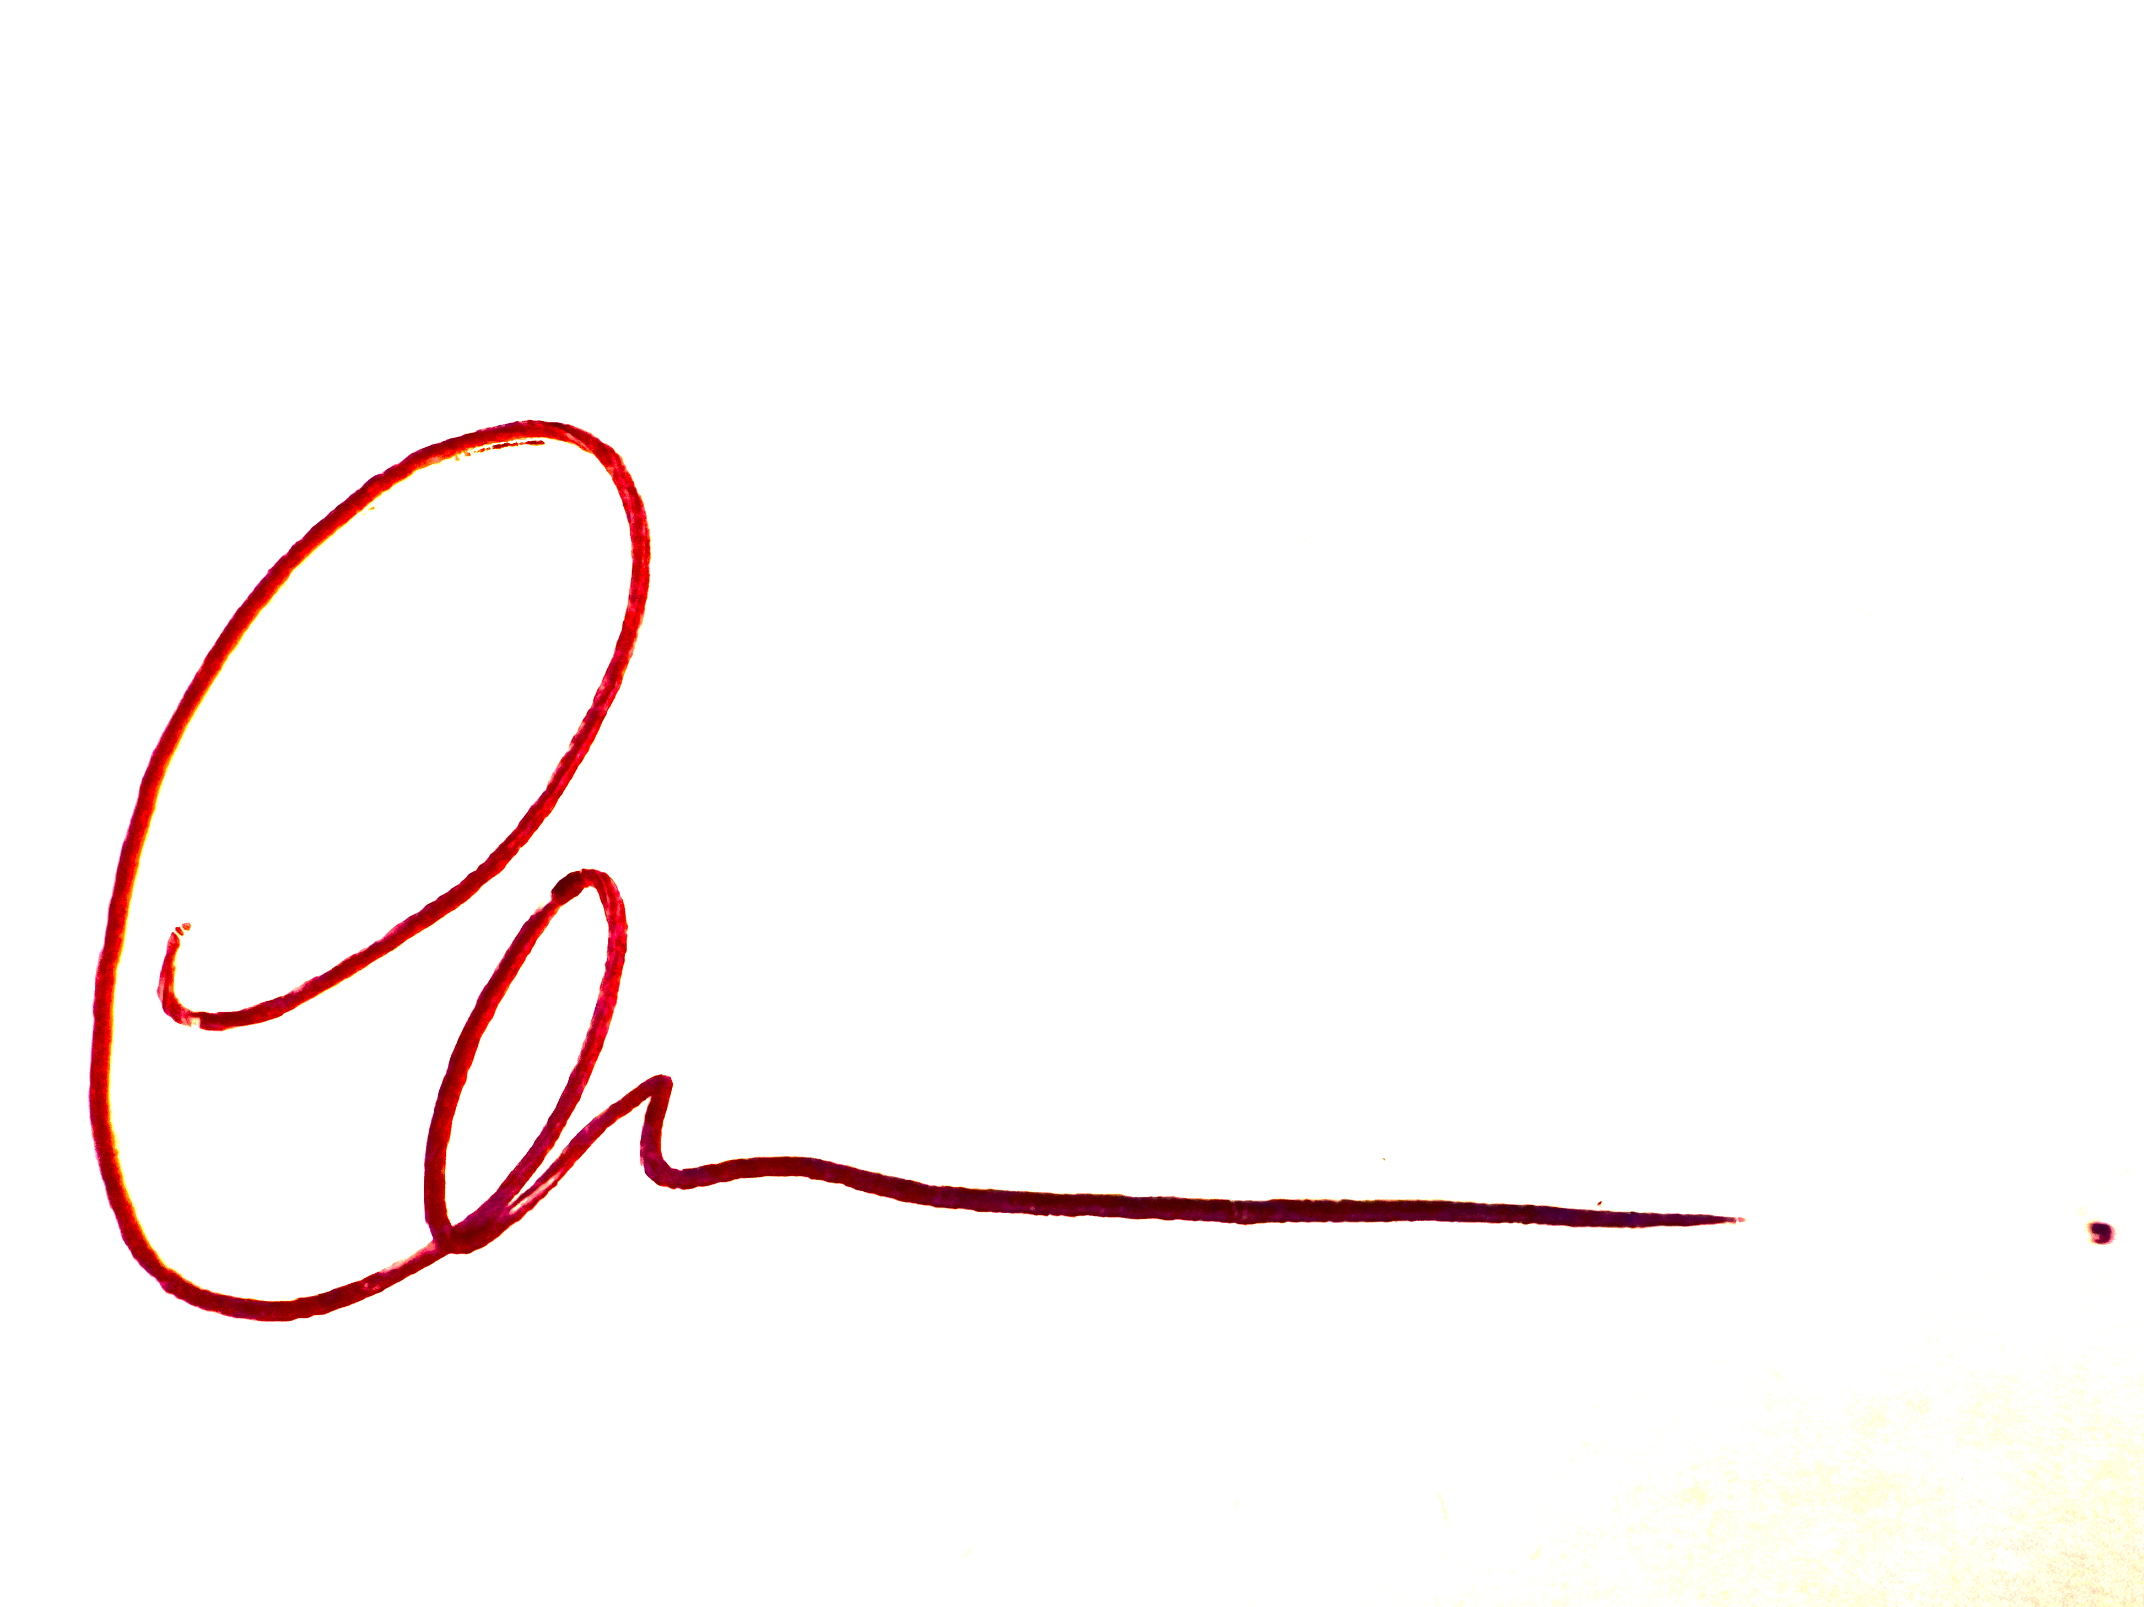Date: 12/09/25

