MINDFULNESS COURSE (MBCT-L)
Offering skills both to meet the difficulties & stresses of life
& to flourish!

8 Week, on-line course, beginning Wednesday October 5th
FREE TASTER SESSIONS
Wednesday 13th July: 10am to 11am
Wednesday 7th September: 10am to 11am
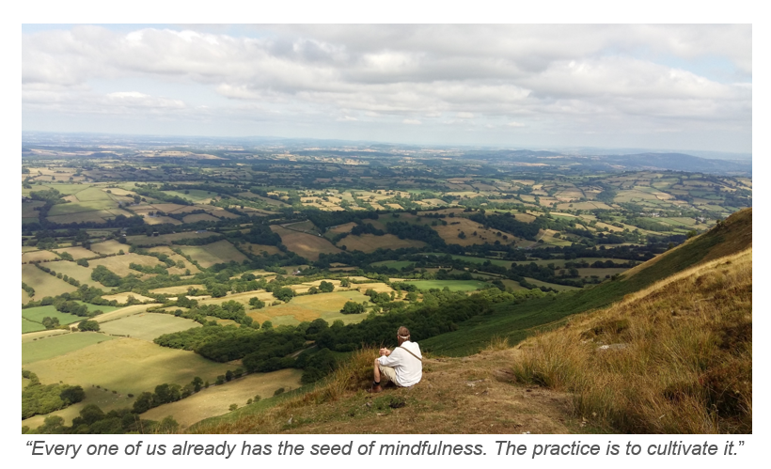

The course will run on Wednesday mornings: 10am to 12.15

5th October to 30th November (missing 25th Oct)

+ half-day on Saturday 19th November

COST: Sliding Scale of £120 to £220
This is a Mindfulness Based Cognitive Therapy Course for Life (MBCT-L), an in-depth programme intended to cultivate lasting and sustainable change. Mindfulness Based Cognitive Therapy is well researched and has been shown to alleviate: anxiety, depression, stress and chronic pain and also to enhance mental & physical well-being

Teacher
Susie Stead is a freelance mindfulness teacher, trained and accredited by the Oxford Mindfulness Centre and teaches there - https://www.oxfordmindfulness.org/people/susie-stead/, also see her website: www.susiestead.com

For further information, please contact: Chris Smith, Development Manager,
Community Centre @ Christ Church,
Mob: 07582 305760 Email: chris@christchurchswindon.co.uk

