Minutes of Blunsdon’s Eighth Parish Council Meeting of 2025/26 held on Monday 4th August 2025 at 7.30pm. This meeting was held at Blunsdon Village Hall.
Cllr Members Present: Cllrs Ian Jankinson (IJ), Jim Tayler (JT), Ian Selwood (IS), Peter Hughes (PH), Cllr Kingsley Poulton (KP) Paul Weston (PW), Nick Gardiner (NG) & Sandra Keates (SK)
Ward Councillor Present: Cllrs Weisinger and Manro
Members of Public - 14
Officers: Debbie Braiden (RFO/Clerk) (DB) Claire Boles (A/Clerk) (CB)
_________________________________________________________________________________________
25/98 APOLOGIES:
Apologies received from Cllr Nash
25/99 DECLARATIONS OF INTEREST
1 No declarations of interest from councillors on items on the agenda were received.
2 No written requests for dispensations for disclosable pecuniary or non-pecuniary
interests were received, therefore, no requests for dispensation were made.

25/100 REPORTS
1. REPORTS FROM WARD COUNCILLORS - None
2. RECESS – All residents spoke regarding planning application S/25/0809
Resident 1:
- Identified nine Highworth circles within the Rivan site using photographic evidence, including two heritage inclusion zones of national importance.
- The site lies within 1.5 km of a Scheduled Ancient Monument (SAM).
- Images have been made available to Blunsdon Parish Council (BPC).

Resident 2 (Ex-Chartered Surveyor):
- Noted that two industrial buildings already operate in the area, using the road for HGVs and large machinery, which would not constitute a valid objection.
- Cited five accidents over 20 years, none involving HGVs, suggesting SBC would not consider HGVs a safety concern. Plus, planning documents indicate traffic marshals will be in place.
- Landscape impact appears minimal, with the site occupying less than 1% of the panoramic view. Gas containers and water bladders are small in comparison to an existing nearby barn. In addition, the tree and plant screening would further obscure visibility of domes and containers.
- Flood assessment is currently satisfactory, and an insurance policy is in place.
Resident 3 (Front Lane Resident):
- Raised concerns about increased traffic at the junction near Newlands Farm, which is already under pressure. And so, believes this poses a heightened risk to pedestrians.
- Quoted current state of the lane having subsidence, broken up in parts and no passing places.
- Noted discrepancies between the presentation by Rivan Industries and the actual design of the domes.
- Non communication from Rivan and requested further details on the plant’s construction and operation.
Resident 4:
- Challenged the accident data cited by Resident 2, stating it reflects a time of lower traffic volumes.
- Requested more information on road widening plans.
- Expressed concerns about the high fencing, animal access, and emergency access for fire services.
- Emphasized that the site is a greenfield heritage location, warranting careful consideration.
Resident 5:
- Highlighted the hazardous nature of local roads due to the lack of footpaths.
- Disputed the frequency of HGVs, stating they are rarely seen despite nearby industrial sites.
- Requested a detailed specification of the production process.
Resident 6:
- Disagreed with claims of minimal landscape impact, stating the model shows clear visibility of gas domes.
- Noted that noise levels at the site boundary are now reported at 45 decibels, which differs from earlier presentations.
Resident 7:
- Raised general concerns about conservation in the area. Found noise levels and height have increased significantly.
Cllr Ian Jankinson: Distributed a report with rules for objections at the Ward Councillors’ Surgery, outlining queries and concerns requiring further information regarding the Rivan Industries proposal.
Ward Cllr Munro: Clarified that Swindon Borough Council (SBC) will only consider factual data and statistics when reviewing the application.
25/101 MINUTES
MINUTES FROM 21st July 2025 MEETING
1. Proposed by Cllr Selwood, seconded by Cllr Weston, all agreed they be accepted as a true record – the minutes were approved and signed by the Chairman.
2. REVIEW ACTION POINTS FROM PREVIOUS MINUTES
Ongoing – Items outside the control of BPC, awaiting update.
In Progress –BPC actions in progress, with confirmation due at the next meeting.
Closed – Action completed; item to be removed from the list.

No | Previous Meeting Action Points | Assigned to: | Status:
1 | Footpaths, The Haul Road: Ward Cllr Gardiner to action a campaign for road closure. Awaiting feedback from Deputy Chief Executive. An alternative option if the road is not closed would be for SBC to take on as a major road with paths & lighting. National Highways/SBC have carried out a further site visit, and a report of the visit will be provided. The road has a temporary closure which has not been reported to SBC, it is presumed that this is for short term emergency works to be carried out. | Cllr Gardiner | Ongoing
2 | Footpaths, The Haul Road Section 106: A response is still due from SBC or the Section 106 claim (This was offered by the developers that had not been claimed, further clarification on how to claim this would be required). | Cllr Gardiner | In Progress
3 | Openreach: on behalf of Virgin O2 are carrying out groundwork throughout the village to provide broadband to residents. Project to be monitored. No reply has been received on project updates from contractors. A request should be made in the magazine for all residents to register their interest in broadband with Virgin 02 and Openreach to gain momentum to the project. | Cllr Selwood | Ongoing
4 | Traffic: SBC are expecting an increase in funding to assist with cycle & walking schemes. The new Swindon Plan includes proposed 530 additional housing at the end of Tadpole, near the school and surgery, this will affect access at the Cold Harbour, Ermin Street & Blunsdon Hill if approved and a re-shape of paths/road would be required. | Cllr Jankinson | Ongoing
5 | PC office build/unit: Order placed for new unit. Invoice approved & ESPO framework processed. Awaiting delivery. | RFO | In progress
6 | High Street Path repair: An SBC job for the repair has been logged, however there is a back log so no date yet advised. | Cllr Hughes | Ongoing
7 | Pavilion Extractors: A copy of the quote is required from Cllr Nash for RFO. Quote previously approved by ALL at £244.93. RFO to raise P/O. Cllr Nash/Taylor to authorise work to commence. | RFO, Cllr Nash & Tayler | In progress
8 | Community Building Car charger: Cllr Keates advised that ‘Charge my Street’ will install a second charger if their claim is successful through the driver's insurance. An Assessor was present last week. | Ward Cllr Keates | Ongoing
9 | Kingsdown Development: S106 form still to be signed. Current Reserve Matters Plan not acceptable. | Cllr Jankinson | Ongoing
10 | Millenium Garden paving slabs: Work to slabs, repointing of the walls, trim back hedges & weeding and removal of vegetation.  Work has commenced, Cllr Tayler meeting with contractor for an update on progress. No invoice has been submitted to BPC. | Cllr Tayler | In progress
11 | Staff review policies: amendments required to suit BPC staff. | RFO | In progress
12 | Electric Speed Sign: Awaiting further details from Highways on advice for suitable speed control. | Cllr Hughes | In progress
13 | Ermin Street Notice Board: The noticeboard is now made and will be installed over the next few weeks. | Cllr Tayler | In progress
14 | Broadbush pavement: Excessive growth alongside the pavement on Broadbush, pedestrian’s safe access is restricted. Brambles are now hanging in pathway. Reported to SBC | Cllr Gardiner | Ongoing
15 | Bunker, recreation ground: Base is now complete, await delivery of shed on w/c 25/8/25 August. | Cllr Nash & Tayler | In progress
16 | WP Landscapes: Paving has commenced at the Pavilion, additional topsoil and seed added, will be completed in stages over next week to allow for delivery of shed and weather conditions.1st stage complete however contractor now disputing the job size and quote. Discussion to take place on how to progress with dispute of quoted job. | Cllr Nash & Tayler | In progress
17 | Storage containers: alternative sizes: 1x 20ft and 1x10ft, for use at the Pavilion and MUGA. Advised delivery date is TBA. | Cllr Nash | In progress
18 | Stratton bins: P/O raised. Cllr Nash to meet in GM on date for install. | Cllr Nash & Tayler | In progress
19 | Water Seepage: in the middle of the road on bend at Front Lane & Back Lane. Councilor Jankinson reported to Thames Water. As the water is surface water on the road it should be reported to SBC as poses a potential danger in winter months. | Cllr Jankinson  Ward Cllr Manro | Ongoing
20 | Cemetery – To review:  - RIALTAS package for cemetery  - Epitaph package with mapping  - Parish On-line mapping  - A/Clerk transferring all manual records onto spreadsheet  - Purchase or aerial photography of cemetery for mapping  - Updating of all Cemetery forms and charges sheet  - Check with GM if qualified for headstone checking  - Join ICCM and training | RFO & A/Clerk | In progress
21 | Daikin boiler: A power flush on the system which is not covered on service contract to be booked for September, a quote should be obtained from 3 contractors including Daikin. A valve change should be done at the same time as system would need to be shut down. | Cllr Tayler | In Progress
22 | New verges: add GM Contract to mapping. | RFO | In Progress
23 | Tree report: from Cotswold Tree Surgeon for 2026, awaiting quote. | A/Clerk | In Progress
24 | Caretaker JD: 5 Applications received, meeting to be set up with RFO and Cllr Jankinson to review applicants. It was noted that probation period should be 3 months on all employees. | RFO | In Progress
25 | Dedication gift: for Cllr Compton | Cllr Jankinson | In Progress
26 | GM Contract & Mapping: add the approved quotes for £50 on to main GM contract and mapping system for extra verges along High Street. | RFO/Cllr Selwood | In Progress
27 | Bins: Add square bin to Hyde Road mapping system. | RFO | In Progress
28 | Speed Watch: Cllr Jankinson will provide details of a new speed watch volunteer to Cllr Hughes. | Cllr Jankinson | In Progress
 | NEW Actions from these minutes
29 | Add to next agenda to approve training course for mapping training with Norfolk Council £24 p/person | RFO | In Progress
30 | Add allotment plots to Parish On-line. Clerk to give A/Clerk rights to edit. | Clerk & A/Clerk | In Progress
31 | Clerk to open a Jewson and Wickes account | Clerk | In Progress
 | Actions confirmed as closed
 | Local Swindon Plan: The Local Plan has been received and circulated to all Councilors for their review. A full review of the plan is required, with particular attention to the lack of infrastructure provision in the proposed housing areas, especially Kingsdown, Stubbs Farm, and Turnpike. |  | Closed
 | Electoral Services: arrange for the Register of Interests to be completed. |  | Closed
 | Training for Mapping Online: Parish Online training required for Clerk & A/Clerk. |  | Closed

25/102 PLANNING
1. Planning decisions advised by Swindon BC
Application Number: S/HOU/25/0785/JOPL
Re: Erection of side dormer window and enlargement of existing dormer window.
At: 24 Sutton Park, Blunsdon, Swindon, SN26 7BB
This application has now been WITHDRAWN

Application Number: S/HOU/25/0672/WOODCL
Re: Erection of single storey rear infill extension to include alterations to the existing conservatory and existing side rear extension.
At: 108 High Street, Blunsdon Swindon SN26 7AB
SBC Granted planning permission

Application Number: S/HOU/25/0409/BURGES
Re: Erection of first floor rear extension.
At: 64 High Street, Blunsdon Swindon SN26 7AE
SBC Granted planning permission

Application Number: S/HOU/25/0690/JOPL
Re: Erection of a new roof to facilitate first floor, 2 no. dormer windows to front and rear and erection of a single storey rear extension.
At: Rockley, Hillside Way Blunsdon Swindon SN26 8BU
SBC Granted planning permission

2. New applications deposited from Swindon Borough Council for comments:
Application Number: S/25/0809
Re: Erection of a temporary synthetic fuel facility, solar array and associated Infrastructure.
At: Land Off Little Rose Lane, Swindon
This planning application has been reviewed in detail by Blunsdon Parish Councillors. All public comments raised at the meeting have been carefully considered as part of the review process. Due to the volume and depth of the responses received, a full summary document has been prepared and will be distributed with these minutes. This document captures all relevant feedback, concerns and disputes from the PC and will be submitted in its entirety to Swindon Borough Council (SBC) as part of the Parish Council’s formal response to the application.
Comments: Agreed to Object

NOTE: After this discussion, 8 members of the public left. Leaving 6 remaining.
Application Number: S/HOU/25/0920
Re: Conversion of loft to include increased roof pitch to rear section of existing roof, insertion of roof lights into side roof slope, associated works and erection of 4 bay wooden carport to driveway.
At: 72 High Street, Blunsdon Swindon SN26 7AE
BPC objects to the proposed roof raising and dormer windows, as they do not reflect the character or scale of surrounding properties. The Blunsdon Village Design Statement emphasises that developments should maintain the village’s aesthetic, which this proposal does not. A covenant linked to Blunsdon House Hotel may restrict construction at the front, and previous similar applications in the area have been declined. The temporary nature of the carport may not guarantee exemption from these restrictions.
Comments: Agreed to Object

Application Number; S/25/0865
Re: Erection of 1 no. dwelling and associated works (Variation of condition 2 of S/20/0635- drawings) - (Variation of Conditions 3, 4, 5, 6, 12 and 14 and Removal of Condition 9 from Planning application S/21/1239).
At: Bluebells, 17 Kingsdown Lane Blunsdon Swindon SN25 5DL
Comments: Variation of Condition only – no comments required

3. Correspondence received was in connection to Application Number: S/25/0431 and S/HOU/25/0561 where SBC wrote with notification of the planning meeting on the 12^{th of} August. Cllr Jankinson, Taylor & Gardiner confirmed their attendance. A/Clerk to confirm attendance to SBC.

25/103 FACILITIES
- VILLAGE HALL – No updates.
- GROUNDS MAINTENANCE & OPEN SPACES
- Cllr Taylor has obtained a quote for hedge cutting at the cemetery from GM, cost of £75. This is an extra non-contractual one-off cut. Quotation agreed by all.
- Cllr Taylor will obtain a quote for seeding of prepared areas at Linley Road from GM, following from MUGA construction.
- Cllr Taylor will obtain a quote for a litter pick from GM, to cover Turnpike Road from Kingsdown Lane junction to Hyde farm entrance. It is not recommended that voluntary public should carry this out due to no suitable pathways. Cllr Taylor also approached Gibbs Surfacing regarding littering. Gibbs currently have planning permission for double stack containers but are using area for van sales. Advertising signs have been put up on the roundabout by Turnpike Road. Ward Cllrs to ask for these to be removed.
- COMMUNITY BUILDING – CAFÉ
Cllr Taylor confirmed that Fire Safety Checks responsibility had been handed over to the shop manager. A trial fire evacuation has taken place successfully.
- CEMETERY & ALLOTMENTS –
Additional items have been added to the action points, to review options and agree way forward with digitizing burials. It was discussed and approved for the option of paying A/Clerk additional hours at an overtime rate to transfer burial history records onto Excel spreadsheet. Her hours would be reported to the RFO regularly, funds would be used from the reserved funds of the Ops Manager role. The cost of joining as members of the ICCM and training will be obtained by the RFO.
- PAVILION & RECREATION GROUNDS
RFO to arrange a meeting to discuss the booking of the Pavilion/Recreation area by the football teams, and the charges for booking of the MUGA. JT to obtain a quote to fix the leak in the referee’s room.
25/104 POLICIES
- The review of the New Standing Orders NALC 2025 will be carried forward and addressed at the next Finance meeting on 18 August. The Standing Orders are being reviewed by Cllr Jankinson and will be provided to RFO for consideration.
- The Code of Conduct was reviewed and accepted by all.
- The Retention Policy was reviewed and accepted by all.

25/105 PROJECTS/FACILITIES
1. MUGA –
a) It was approved for the addition of the courts to Lemon Booking at £12 per annum for each court.
b) The charges for tennis and football pitches will be discussed at a separate meeting and presented back to the PC for review/approval.
c) It was approved insurance charge for the MUGA of £146.97, which is the pro-rata payment left until the end of the policy.
d) It was approved to pay the first instalment payment of 50% to PKL Group for £23k for the office unit.
2. ERMIN STREET – To note Oliver has secured a grant from SBC's Trees for Climate tree planting fund. We will receive £30,000 upon completion of the planting work sometime early next year and expect to be paid into 35 Day account. This money is designed to also help with maintenance costs afterwards, but we will receive it all in a lump sum early next year. Cllr Jankinson suggested that a piece of artwork be mounted in recognition of the area, drawings to follow.
3. TRAFFIC CALMING - See action point item 4. Cllr Jankinson also noted that the S106 funding would assist in this project.
4. BROADBAND – See action point item 3.
NOTE: Ward Cllr Munroe & Weisinger left the meeting @ 9.30pm
25/106 CORRESPONDENCE
- Tenant Focus SBC: Loaded on Web/FB, and emailed to Cllrs
- Swindon media release x 8: Loaded on Web/FB, and emailed to Cllrs
- NALC x4: Loaded on Web/FB, and emailed to Cllrs
- The Inside Lane: Loaded on Web/FB, and emailed to Cllrs
- Chief Constable fortnightly update x 2: Loaded on Web/FB, and emailed to Cllrs
- Essential road maintenance: Loaded on Web/FB, and emailed to Cllrs
- Wiltshire PCC: Loaded on Web/FB, and emailed to Cllrs
- Resident complaint about noise on Linley Road car park: Emailed to Cllrs, response required
- Resident enquiry re. access/safety on the Copse: Emailed to Cllrs, response required

25/107 PARISH MATTERS
Cllr Poulton gave apologies for the next meeting.
Cllr Jankinson is in discussions with Hazel Wakefield, who works with Age UK, we are looking at helping, to set up a Dial-A-Ride pick up and drop off at the Community Shop for the elderly. Hazel will attend the next meeting on the 18^{th of} August.
Street Works – add to approve South Swindon’s policy for the next meeting.
25/108 ADDITIONAL AGENDA ITEMS
Finance b/fwd. from 21st July Agenda – The following were approved:
- Payments for approval for 19/6/25 to the 24/7/25
- Payments & Receipts for June 25
- Regular Payments list for June 25

25/109 KEY MESSAGES FOR MAGAZINE/FACEBOOK/WEB
- Thanks to the litter pick team
- Update on MUGA
- Request not to use carpark at MUGA site for ball games.
- Wiltshire 105 meeting
- Request for all residents to register their Broadband interest in Open Reach or Virgin O2

25/110 CLOSE & SUMMONS TO ATTEND NEXT MEETING
- Next month’s Full Council meeting to be held Monday 1st September 2025 at 7.30pm
- Next Finance meeting to be held on Monday 18th August 2025 at 7.30 pm
- Cllr Nash advanced apologies until 18th August.
- There being no further business the Chairman declared the meeting closed at 9.45pm

………………………………......
Signed by Chairman 18th August 2025

SUMMARY OF ACTIONS PROJECT/ACTION POINTS FOR FUTURE

Date Raised June 23
Project/Action Turnpike Parking issues
Status Ongoing

Date Raised 2022
Project/Action Ditch in Kingsdown Lane, SBC awaiting waste plan from Care Home Nov 2022
Status Ongoing

Date Raised 2024
Project/Action Ermin Street Planting Project
Status Review again 2025

REGULAR PAYMENTS LIST
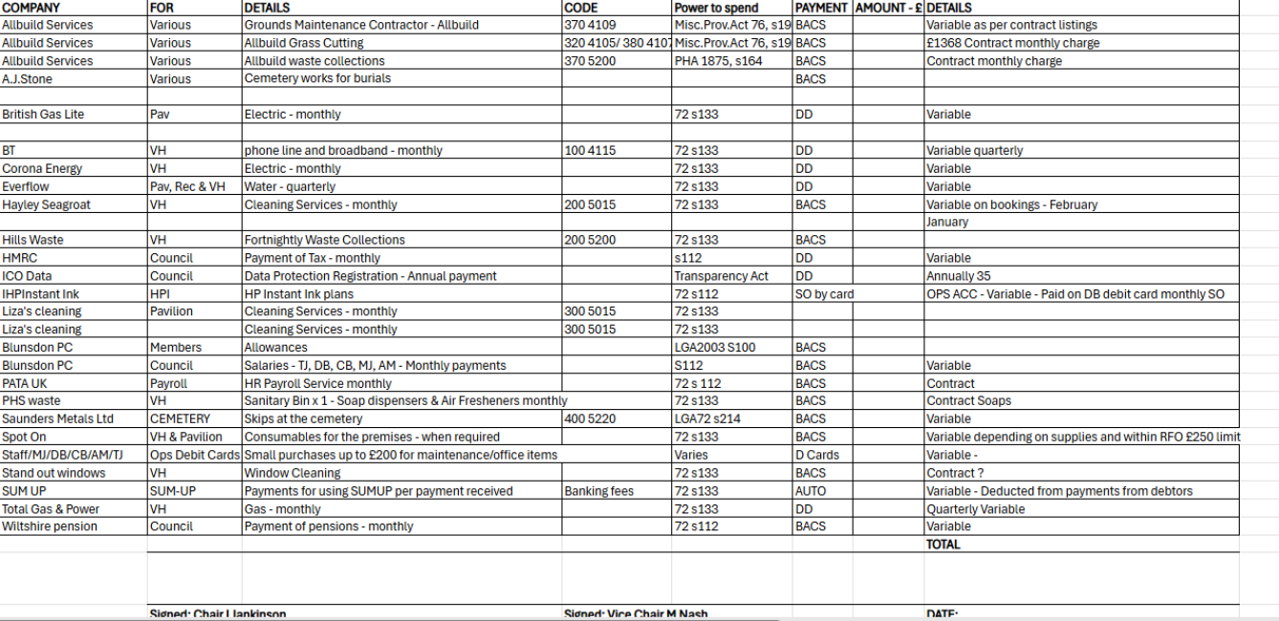
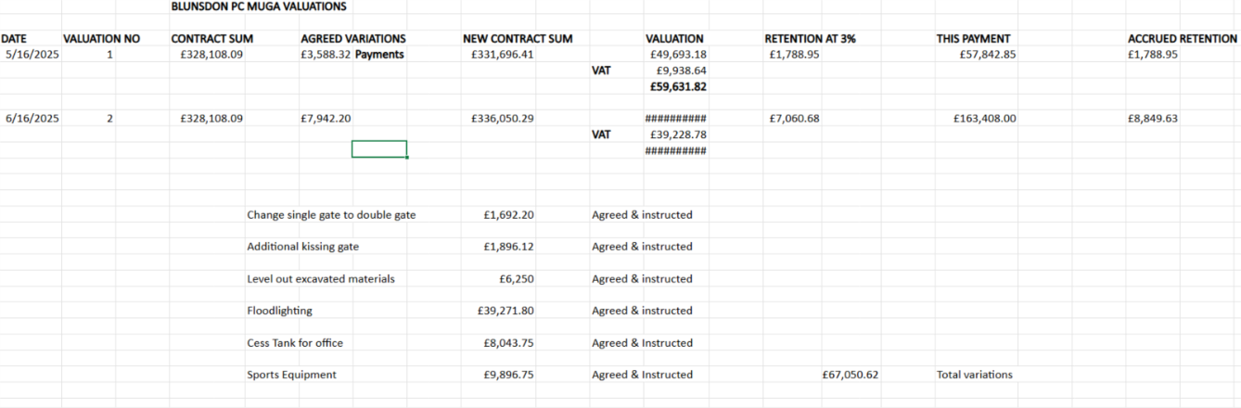
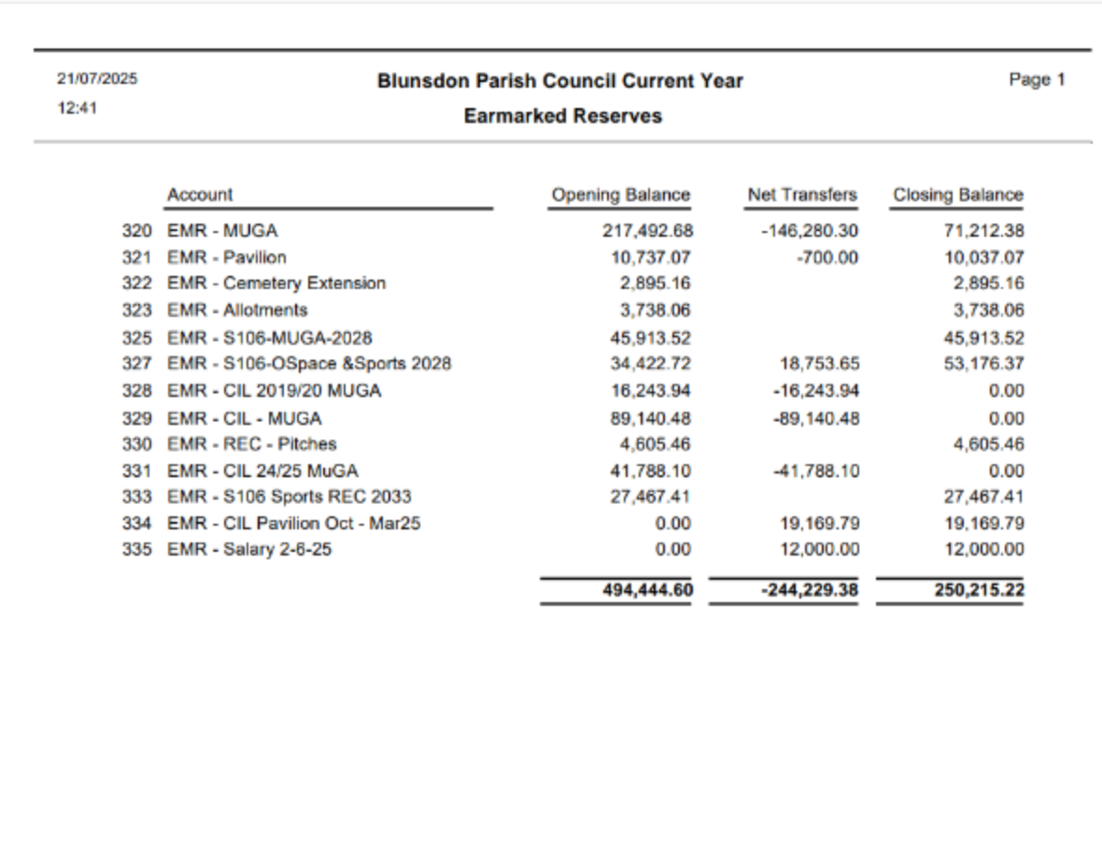
Date: 21/07/2025 Blunsdon Parish Council Current Year  Time: 12:23 Current Bank A/c  List of Payments made between 19/06/2025 and 22/07/2025 |  |  |  |  |  | Page 1
Date Paid | Payee Name | Reference | Amount Paid | Authorized Ref | Transaction Detail
19/06/2025 | Emergency services | BACS063 | 70.00 | RFO July meet | JT copy keys key cabinet VH
19/06/2025 | Garden and Hire Spares Ltd | BACS066 | 29.11 | RFO July meet | 1261144 inv tank vent
19/06/2025 | Jennychem Industrial Chemicals | BACS068 | 75.00 | RFO - JULY meet | Weedkiller MN receipt
19/06/2025 | Jennychem Industrial Chemicals | BACS068 | -75.00 | REVERSAL RFO | Not paid in bank
21/06/2025 | Everflow water | BACS072 | 126.08 | REGULAR | Water July to Aug
23/06/2025 | S & C Slatter | BACS079 | 30,000.00 | June meet | 2nd Certificate MUGA
26/06/2025 | Asgard Secure Steel Storage | BACS067 | 840.00 | May meet  25/32/2 | PF50781 invoice Pav Shed
26/06/2025 | S & C Slatter | BACS080 | 30,000.00 | June meet | 2nd Certificate MUGA
26/06/2025 | S & C Slatter | BACS081 | 73,408.00 | June meet | 2nd Certificate MUGA
27/06/2025 | Liza's Easy Cleaning Services | BACS073 | 61.00 | REGULAR July | June cleaning pav
27/06/2025 | Hayley Seagroatt | BACS074 | 745.00 | REGULAR | VH clean \june
27/06/2025 | S & C Slatter | BACS082 | 30,000.00 | June meet | 2nd Certificate MUGA
30/06/2025 | REF 3 | BACS078 | 1,361.87 | REGULAR JUNE | REF 3 June
30/06/2025 | REF 4 | BACS076 | 404.85 | Not paid see notes | REF 4 June see notes in file
30/06/2025 | REF 4 | BACS076 | -404.85 | not paid see notes | not paid -used against interim
30/06/2025 | REF 1 | BACS077 | 1,825.56 | REGULAR | REF 1 June
30/06/2025 | SUM-UP Payments | BACS093 | 4.48 | REGULAr July 21 June's deductions
01/07/2025 | Saunders Metals LTD | BACS089 | 240.00 | REGULAR 21  July | 018735 inv
02/07/2025 | Daikin Airconditioning UK Ltd | BACS091 | 399.00 | Emergency -  RFO 21-7 | 2102147938 inv Annual contract
10/07/2025 | Allbuild and Landscaping Serv | BACS083 | 2,322.00 | REGULAR July  21 | 3277 invoice
10/07/2025 | Allbuild and Landscaping Serv | BACS084 | 1,770.00 | PO 25/002 | 3278 inv Millennium Gdns clear
10/07/2025 | Lovell Johns Ltd | BACS085 | 480.00 | IJ - July 21 | 583831 inv village maps
10/07/2025 | Guy Davies Architects Ltd | BACS087 | 610.00 | Meet 7th July | GDA-2405-02 invoice
10/07/2025 | Jennychem Industrial Chemicals | BACS088 | 75.00 | July 21 | Martin Nash weedkiller
10/07/2025 | Thames Water Utilities Ltd | BACS090 | 252.00 | Meet 7th July | CB02500975 MUGA
16/07/2025 | S & C Slatter | BACS104 | 30,000.00 | JULY 21 | 3rd Cert MUGA
17/07/2025 | S & C Slatter | BACS105 | 30,000.00 | JULY 21 | 3rd Cert MUGA
18/07/2025 | S & C Slatter | BACS106 | 30,000.00 | July 21 | 3rd Cert MUGA
21/07/2025 | S & C Slatter | BACS107 | 37,885.51 | July 21 | 3rd Cert MUGA
22/07/2025 | PATA UK | BACS086 | 133.95 | REGULAR July 21 | 24/1254/PPS inv
22/07/2025 | Stand Out Window Cleaning Serv | BACS094 | 150.00 | REGULAR July 21 | Internal and external
22/07/2025 | Petrol Station Penhill | BACS095 | 7.20 | July 21 | Fuel MUGA
22/07/2025 | Amazon EU | BACS096 | 7.59 | JULY 21 | Sprayer lance for weedkillerJT
22/07/2025 | TSP Kar Hire Ltd | BACS097 | 81.95 | JULY 21 | Ford Tipper transit MUGA JT
22/07/2025 | Emergency Security Services | BACS098 | 110.00 | JULY 21 | 2 x gear box door lock shop
22/07/2025 | Wickes | BACS099 | 33.60 | July 21 | Lock for bin at pavilion
22/07/2025 | AWBS Ltd | BACS100 | 98.72 | JULY 21 | Shed base REC JT
22/07/2025 | Jewson | BACS101 | 29.08 | JULY 21 | Footpath sign post JT
22/07/2025 | Currys PC World Business | BACS102 | 179.10 | JULY 21 | Small fridge VH IJ

Date: 21/07/2025 Blunsdon Parish Council Current Year  Time: 12:23 Current Bank A/c  List of Payments made between 19/06/2025 and 22/07/2025 |  | Page 2
Date Paid Payee Name Reference | Amount Paid Authorized Ref Transaction Detail
22/07/2025 Allbuild and Landscaping Serv BACS103 | 4,945.50 REGULAR JULY GM contract July 21
22/07/2025 Morrisons BACS034 | 9.10 RFO correction IJ - TOP up for underpayment
Continued on Page 2 Total Payments 308,290.40

Date: 20/07/2025  Time: 13:52 | Blunsdon Parish Council Current Year  Operations Account  List of Payments made between 19/06/2025 and 22/07/2025 |  | Page 1
Date Paid Payee Name | Reference | Amount Paid Authorized Ref Transaction Detail
25/06/2025 Screwfix | OPS013 | 166.47 RFO - July meet A22105807676 order no. PPE
30/06/2025 HPI Instant Ink | OPS014 | 13.49 REGULAR 21 DB printing June  July
Total Payments 

TOTAL PAYMENTS FOR MONTH £308,470.36

