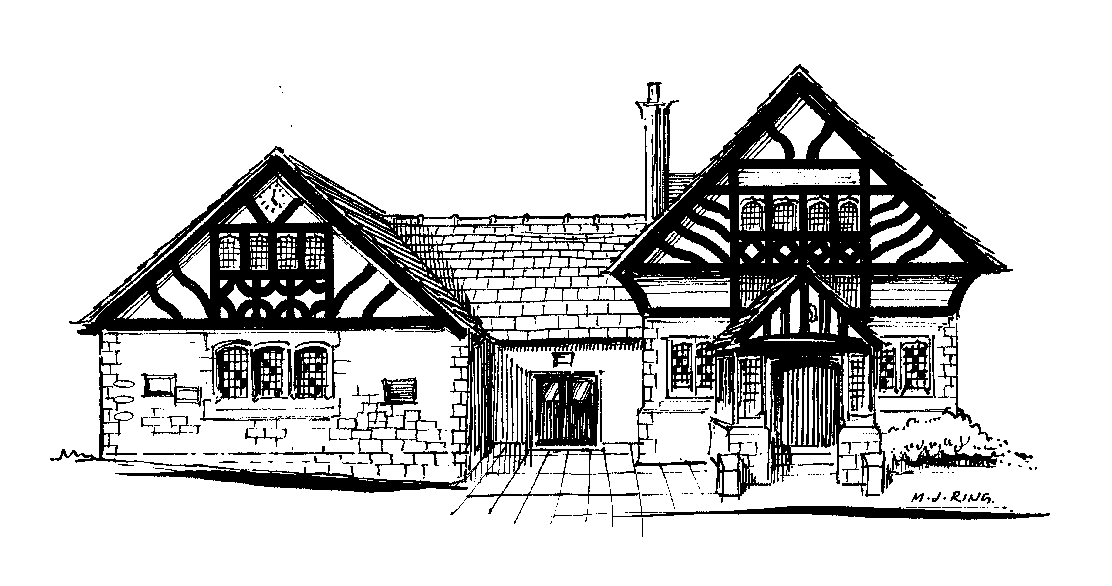

Willaston Memorial Hall

The Green, Neston Road, Willaston, CH64 2XR Charity No 520090

Website: www.willastonmemorialhall.co.uk
Email: Bookings.MemorialHall@gmail.com

COMMITTEE OF TRUSTEES

Elected
Catherine Jones (Chair) 0151 327 1850
Vacant (Vice Chairman)
Doreen Francey (Secretary)
Lisa Nicholls (Treasurer)

Representatives
Vacant Willaston Residents’ and Countryside Society (This organisation is defunct)
Sheena Chalmers Willaston Girlguiding units
Val Fisher Willastonhey W.I.
Vacant Darby and Joan (This organisation is defunct)
Jackie Jenkins Country Market
TBC Willaston Horticultural Society
TBC Hadlow Green Singers
Vacant S4YC
Vacant Willaston Badminton Society (This organisation is defunct)
Paul T Cox Friends of Hadlow Road Station
(Appointed under clause 9 of the Trust Deed)

Co-opted
Brian Greenhalgh
Ian Corcoran

Contact numbers for trustees and keyholders are available upon reasonable request.

