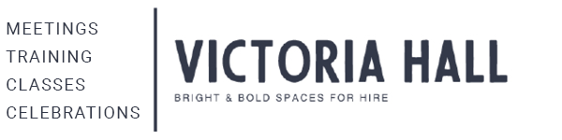

Fire
In the event of a fire, please leave the building by the nearest fire exit and stand outside the gate at the assembly point at the (Green & White) sign, the centre manager will manage the situation until the emergency services arrive.

Furniture: Please do not drag furniture as it damages the flooring

Tables: please clean before putting away

Stack chairs onto their trolley correctly and return tables to the storage cupboard. There is a blue tool to help fold away the table legs – ask staff you need it.

It is not permitted to bring any type of chafing dish/fuel into VH
Tables – use table coverings if serving food or during arts & craft activity
No glitter or sand permitted in any Victoria Hall spaces
Ensure balloons are secured/weighted down
Please DO NOT puncture balloons in any space
Clean up drink spillages, food & cake from tables, chairs & floors

Toilets: Please DO NOT put nappies in the toilet, use the waste bin provided.

Rubbish: Please tidy up, clear away and leave the space clean & tidy.
All rubbish must be bagged & taken to the Bin store

Hire period: Please be mindful of your start & finish time!

WIFI: Guest - Victoria Hall Harrow. PW - VictoriaHallHarrow

If you have any questions, please don’t hesitate to ask.

