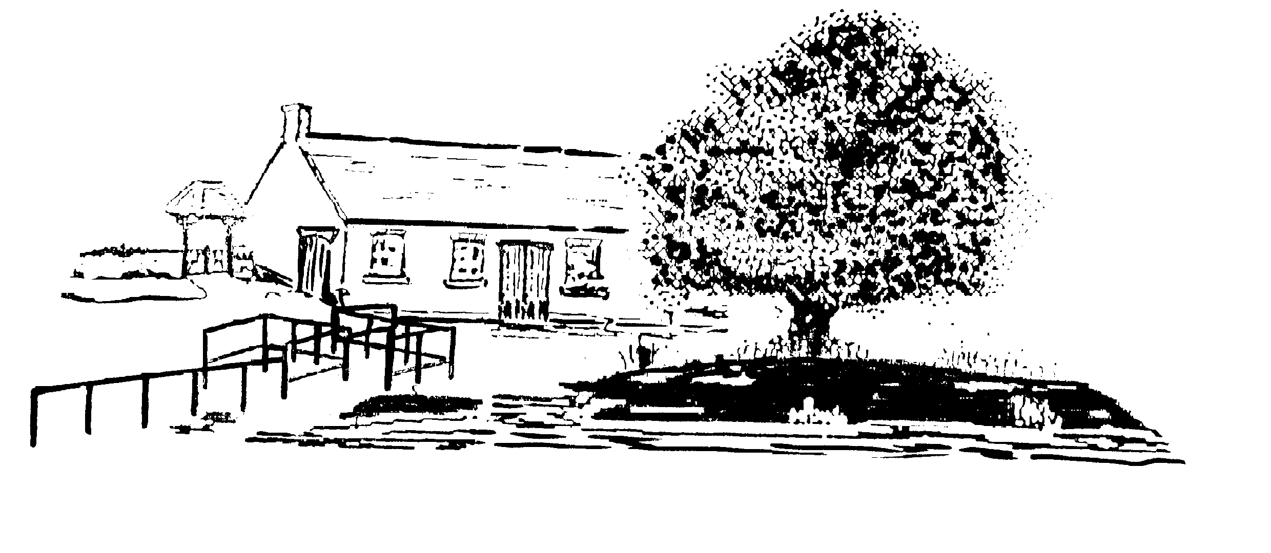
THORNBOROUGH VILLAGE HALL

LOST PROPERTY

The TVH committee do not accept any responsibility for property lost or stolen from the premises.

- If you find or lose something please contact the Hall Manager - details can be found on our website

https://thornboroughvillagehall.com

- TVH will retain lost property for one calendar month and advertise the item on our village Facebook page Thornborough eNews.

- Items that are unclaimed will be sold to raise TVH funds, offered to Thornborough residents or recycled as appropriate.

November 2025

