Chair Storage
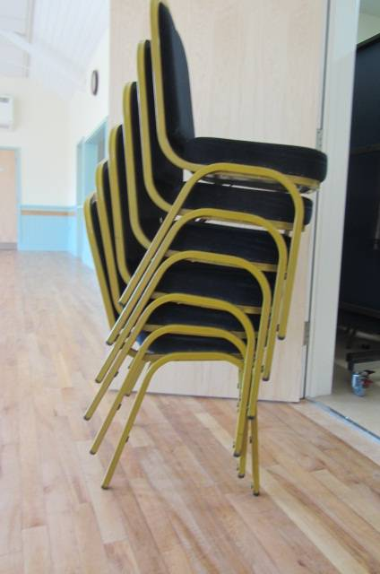 WRONG – DANGEROUS! 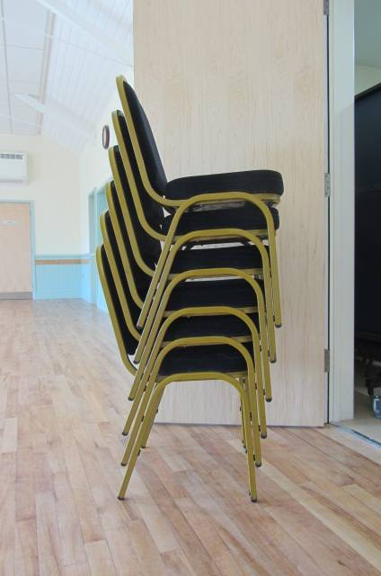 RIGHT - SAFE 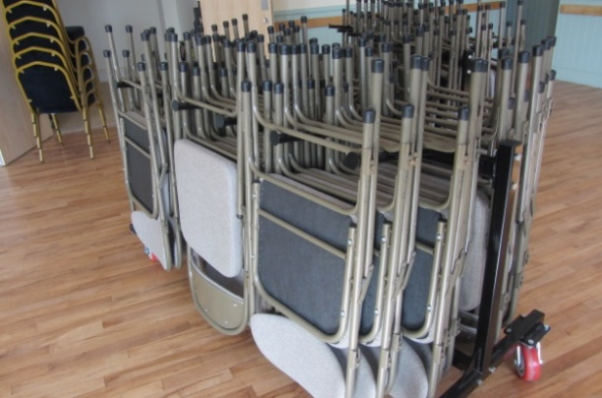 WRONG – Facing different ways and overstacked.
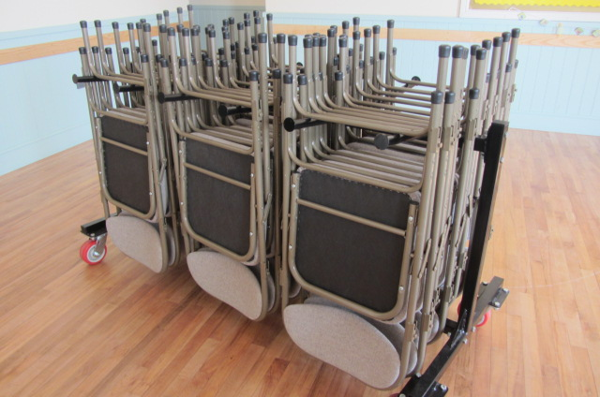

RIGHT – 5 chairs on each arm and all facing the same way. 30 chairs per trolley
Please stack chairs as shown. It takes no longer to do and makes things safe and much easier for other hall users.
Despite these instructions being given to all hall users, they are often ignored. You risk a deduction being taken from your deposit if they are not adhered to. If they were stacked correctly at the start of your session, but are not at the end of it, an automatic deduction will be made from the deposit.

SSVH Management Committee
February 2024

