Pineapple House  
Conditions of Hire and Information

**Green Room**

Dads Lane Community Association, 171 Pineapple Road,

Stirchley, Birmingham, B30 2SY. Tel 07410 146 239

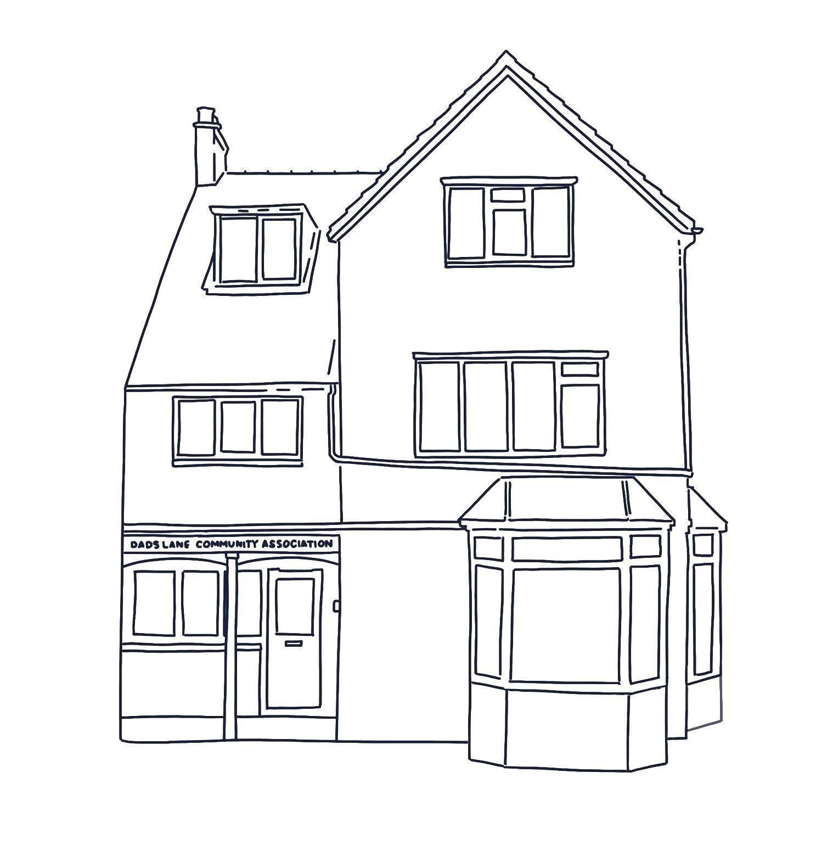

# About Pineapple House

# Pineapple House is home to Dads Lane Community Association and is situated on the corner of Pineapple Road and Cartland Road in Stirchley, Birmingham. The Association has been based in Pineapple House since the 1930s and has long provided a space for local residents to meet, share common interests and respond to needs. Thanks to funding from the National Lottery and other grants, most of Pineapple House has recently been renovated, breathing new life into it. This renovation ensures that local residents in Stirchley, Hazelwell and Kings Heath have a place to meet each other, improve their wellbeing and build community for many future generations. Dads Lane Community Association is committed to ensuring that Pineapple House is a safe and welcoming space for all individuals regardless of age, disability, gender and gender reassignment, race, religion or belief, sex, or sexual orientation.

# Dads Lane Community Association is a Charitable Incorporated Organisation (CIO) which is governed by local Trustees. Day to day activities are overseen and facilitated by a full time Development Worker, a part time Support Worker and a wonderful and diverse team of volunteers. The Advisory Group, made up of local residents, also meets regularly to ensure that all activities are in line with what the community wants and needs. All income and donations contribute towards running costs and activities, along with any grants which are awarded.

**Green Room Hire Conditions and Information**

We are really pleased that you have chosen to hire the Green Room. We hope you find the space calming and positive.

* To **access** the building when there is no one else present please enter your unique code followed by a star, onto the keypad which can be found on the yellow door at the entrance on Pineapple Road. This code will be the same as your booking number for that session e.g. 1178*. This number can be found on your Pineapple House booking account.
* The doorbell speaker is located in the ground floor kitchen. If you are expecting clients / visitors please discuss with them how they will let you know they have arrived. You might also find it helpful to share our “How to find us” information from our website with any clients and visitors https://dlca.co.uk/page/contact.
* Please also ensure that you only **allow people into the building** who are part of your booking, even if they seem to have a good reason to enter.
* There are 3 **toilets** on the first floor, one of which also has a shower which everyone is welcome to use (toiletries and towels not provided).
* **Heating** is set to come on during the colder months of the year only. During this time you might find it helpful to adjust the thermostatic valve on the radiator or the thermostat which is located on the wall next to the first floor toilets.
* Please feel free to **rearrange the tables and chairs as needed**. All tables can be rolled into place and folded down or up by pulling up the lever at the end of the table. Extra chairs can be found in the Yellow Room - please knock before entering in case there is a group using that room.
* **Refreshments** are included in your booking and can be found in the first floor kitchen (orange door). If you store any items in the **fridge** please remove these at the end of your room hire as we must follow strict Food Hygiene procedures. In order to protect all users we are a **nut free** space. And unless you have received permission from Trustees at the time of booking please do not consume any **alcohol** at Pineapple House.
* During your booking you are welcome to use the **Lockers** in the Green Room, to open please hold the blue fob next to where the locker door opens, about ⅓ of the way down. Once unlocked you will hear a short burst of beeps then the door will open. Due to multiple users of these lockers we are unable to store anything for you outside of your booked session.

* **The Nook** can be found at the top of the stairs to the 2nd floor. You might like to sit there for a few minutes to find some peace or to take a phone call. It can also serve a place for people to wait for appointments.
* **Cleaning products** can be found in the bottom drawer in the first floor kitchen. Please leave the premises in the condition you found them and immediately report any faults or damage to staff on 07410146239.
* **Recycling** can be placed in the recycling bin located in the first floor kitchen. Please take away any **bulky rubbish** to dispose of elsewhere.
* If you bring any mains **electrical equipment** with you please ensure that it is in good working order with no loose wires or broken parts as this could cause an electrical shock or fire.
* A **First Aid** box is located on the windowsill in the first floor kitchen. Please make a note of any contents you have used so that we can ensure it is restocked as soon as possible.
* Images captured on **CCTV** inside the building are stored for 7 days, after which they are automatically deleted; no sound is recorded. If you wish to deactivate the camera in the Green Room during your booking please simply unplug it from the power source.
* Our **Cancellation Policy** is that in the event of an unforeseen circumstance bookings can be cancelled up to 48 hours before the booking is due to take place and a credit note will be issued. If you have any queries about this please speak to Sarah or Steve.
* In order to be respectful of our neighbours please ensure that any evening events end at 9pm. This allows you time to tidy up and **vacate the premises quietly by 9.30pm**.
* A **security alarm** is in place whilst the building is empty You must set the alarm before exiting the building by following the instructions provided in a separate page called Entry and Exit Instructions. Please note that the light halfway up the first floor stairs will turn on and off automatically when it senses movement.
* In the event of a **fire or emergency** the emergency alarm will sound automatically or you can raise the alarm by lifting the plastic cover on the call point situated outside the Green Room and pressing the black circle until it triggers the fire alarm. Evacuate everyone in your group to the garden and make sure that everyone is accounted for. Please call 999 to request an emergency service then phone Steve or Sarah using the number above.
* Location of key safety hazards or other fire related equipment

• Gas supply shut off: cupboard next to the front door onto Pineapple Road

• Mains fuse box: Small cupboard in the lobby

• Mains water inlet: underneath the ground floor kitchen sink

• Location of fire alarm panel: lobby