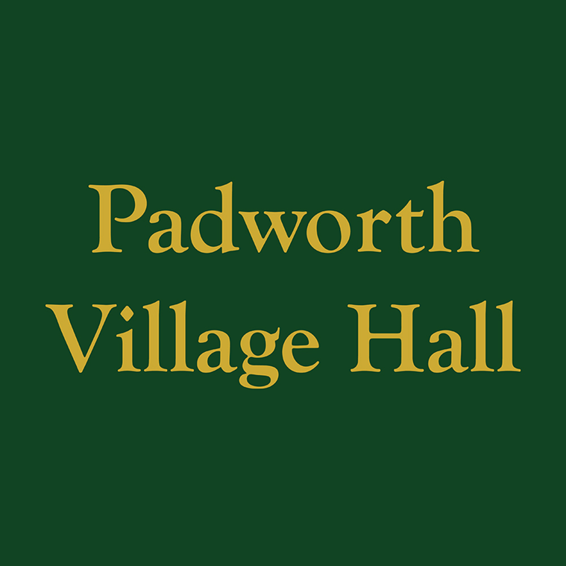
CONDITIONS OF HIRE OF PADWORTH

VILLAGE HALL AND GROUNDS

JANUARY 2026

Standard Conditions of hire

These standard conditions apply to all hiring of the village hall and grounds (hereafter called “the premises”). If the Hirer is in any doubt as to the meaning of the following, they should clarify at time of booking.

These conditions of hire shall prevail in any contract for the hire of the premises, and no variation thereof shall be permitted, without prior written consent of the committee. Any serious breach of these conditions shall entitle the Padworth Village Hall Committee (PVHC) to take such steps as are necessary to rectify the same, including termination of the function or activity, and the vacation of the premises by all persons for whom the hirer is responsible.

All applications for use of the premises can be made on the application form, EMAIL or by phone. The Committee at its absolute discretion shall be entitled to reject any application or refuse admission to the premises to any individual, group or organisation without assigning any reason to such rejection or refusal. All bookings are subject to confirmation by booking manager/ committee and to payment of the appropriate fees as agreed at the time of booking. No bookings will be accepted from any person under the age of 18 years of age.

Age
The Hirer, not being a person under 18 years of age, hereby accepts responsibility for being in charge of and on the premises at all times when the public are present and for ensuring that all conditions, under this Agreement, relating to management and supervision of the premises are met.

Supervision
The Hirer shall, during the period of the hiring, be responsible for: supervision of the premises, the fabric and the contents; their care, safety from damage however slight or change of any sort; and the behaviour of all persons using the premises whatever their capacity, including proper supervision of car parking arrangements so as to avoid obstruction of the highway. As directed by the Committee, the Hirer shall make good or pay for all damage (including accidental damage) to the premises or to the fixtures, fittings or contents and for loss of contents.

Use of premises
The Hirer shall not use the premises for any purpose other than that described in the Hiring Agreement and shall not sub-hire or use the premises or allow the premises to be used for any unlawful purpose or in any unlawful way nor do anything or bring onto the premises anything which may endanger the same or render invalid any insurance policies in respect thereof nor allow the consumption of alcohol thereon without written permission.

Gaming, betting and lotteries
The Hirer shall ensure that nothing is done on or in relation to the premises in contravention of the law relating to gaming, betting and lotteries.

Licensable activities
The premises is not licensed for the sale of alcohol, dance, live and recorded music, and play. If required a Temporary Entertainments licence will need to be purchased and displayed at the event.

The maximum number of persons allowed in the main hall on each occasion is limited to 80 (This may be less depending of the activity / use of hire).

The Hirer shall ensure that no activity is permitted on the premises in breach of the Performing Rights and other copyright legislation and any other statutory controls for the time being in force.

Public safety compliance
The Hirer shall comply with all conditions and regulations made in respect of the premises by the Local Authority, the Licensing Authority, the premises’ Fire Risk Assessment or otherwise, particularly in connection with any event which constitutes regulated entertainment, at which alcohol is sold or provided or which is attended by children. The Hirer shall also comply with the premises’ Health and Safety policy.

  - The Hirer acknowledges that they have been advised that all information relating to the following is provided on the hall notice boards:
- The action to be taken in event of fire. This includes calling the Fire Brigade and evacuating the premises.
- The location and use of fire equipment (see diagram of location on hall noticeboard).
- Escape routes and the need to keep them clear.
- Method of operation of escape door fastenings.
- Appreciation of the importance of any fire doors and of closing all fire doors at the time of a fire.

  - In advance of a theatrical or entertainment event the Hirer shall check the following items:
- That all fire exits are unlocked including both front doors and panic bolts are in good working order.
- That all escape routes are free of obstruction and can be safely used.
- That any fire doors are not wedged open.
- That exit signs are illuminated.
- That there are no obvious fire hazards on the premises.
- That all public and participants are familiar with the procedure for evacuation in the event of an emergency.

  - It is the responsibility of the Hirer to ensure compliance with all food hygiene and health and safety regulations and to ensure that adequate safeguards are in place to protect the well-being of the disabled, children and vulnerable adults.

For theatrical and entertainment events a person over the age of 18 years must be appointed to be responsible for health and safety when such events take place. At least two other persons over the age of 18 years must also be appointed and instructed in the procedure for evacuation in case of an emergency.
At the start of each theatrical or entertainment performance the location of fire exits, emergency lighting and firefighting equipment are indicted to the audience and the fire alarm and evacuation procedure is explained.

In the event of an emergency all entertainment shall cease and the public and participants must be instructed to leave the premises in a calm and orderly manner. The relevant emergency service must be contacted as soon as a problem is discovered.

Means of escape
  - All means of exit from the premises must be kept free from obstruction and immediately available for instant free public exit.

  - The emergency lighting supply illuminating all exit signs and routes must be left on during the whole of the time the premises are occupied and must not be interfered with by the Hirer.

Outbreaks of fire
The Hirer shall call the Fire Brigade to any outbreak of fire, however slight, and details thereof shall be given to the Committee.

Health and hygiene
The Hirer shall, if preparing, serving or selling food, observe all relevant food health and hygiene legislation and regulations. In particular dairy products, vegetables and meat on the premises must be refrigerated and stored in compliance with the Food Temperature Regulations. The premises are provided with refrigerators, freezer and thermometer.

Electrical appliance safety
The Hirer shall ensure that any electrical appliances brought by them to the premises and used there shall be safe, in good working order, and used in a safe manner in accordance with the Electricity at Work Regulations 1989. Evidence that external appliances have been PAT tested may be required.

Where a residual circuit breaker is provided the hirer must make use of it in the interests of public safety.

The use of extension leads by the Hirer where one extension is plugged into another is not permitted.

Insurance and indemnity
  - The Hirer shall be liable for:

- the cost of repair of any damage (including accidental and malicious damage) done to any part of the premises including the curtilage thereof or the contents of the premises
- all claims, losses, damages and costs made against or incurred by PVHC, volunteers, agents or invitees in respect of damage or loss of property or injury to persons arising as a result of the use of the premises (including the storage of equipment) by the Hirer, and
- all claims, losses, damages and costs made against or incurred by PVHC, volunteers, agents or invitees as a result of any nuisance caused to a third party as a result of the use of the premises by the Hirer, and subject to sub-clause (b), the Hirer shall indemnify and keep indemnified accordingly each member of PVHC and the premises’, volunteers, agents and invitees against such liabilities.

  - PVHC shall take out adequate insurance to insure the liabilities described in sub-clauses (a)(i) above and may, in its discretion and in the case of non-commercial hirers, insure the liabilities described in sub-clauses (a) (ii) and (iii) above. The PVHC shall claim on its insurance for any liability of the Hirer here under but the Hirer shall indemnify and keep indemnified each member of the PVHC and the premises’ volunteers, agents and invitees against (a) any insurance excess incurred and (b) the difference between the amount of the liability and the monies received under the insurance policy.

  - Where the PVHC does not insure the liabilities described in sub-clauses (a)(ii) and
(iii) above, the Hirer shall take out adequate insurance to insure such liability and on demand shall produce the policy and current receipt or other evidence of cover to the Booking manager. Failure to produce such policy and evidence of cover will render the hiring void and enable the Booking manager to rehire the premises to another hirer.
The premises is insured against any claims arising out of its own negligence.

PVHC shall have no liability for any injury, loss or damage, whosoever caused to any person or property arising during or as a result of any functions or other activities outside of the subject matter of the hire contract, and the Hirer shall indemnify the PVHC against all such claims without reservation.

Accidents and dangerous occurrences
The Hirer must report all accidents involving injury to the public to the Booking manager as soon as possible and complete the relevant section in the premises’ accident book. Any failure of equipment belonging to the premises or brought in by the Hirer must also be reported as soon as possible.

Certain types of accident or injury must be reported on a special form to the Incident Contact Centre. This is in accordance with the Reporting of Injuries, Diseases and Dangerous Occurrences Regulations 1995 (RIDDOR). The Incident Contact Centre can be contacted in any of the following ways:
- Telephone: 0845 3009923
- Website: www.riddor.gov.uk or via the HSE website: www.hse.gov.uk

Explosives and flammable substances
The Hirer shall ensure that:
  - No real flames, explosives or highly flammable substances are brought into, or used in any part of the premises. Real flames do not include candles. Where candles are used as part of a celebration e.g. birthday candles on a cake, then no further action is needed. Where candles are to be used as part of table decorations, then tea light type of candles are allowed provided they are placed on non-combustible material, e.g. candle holder or plate. Where other types of candles are proposed, then the prior permission of the Booking manager must be sought. On no account are candles allowed on window sills, work tops etc.

  - No internal decorations of a combustible nature (e.g. polystyrene, cotton wool) shall be erected without the consent of PVHC. No decorations are to be put up near light fittings or heaters.

  - Where the Hirer proposes to use theatrical pyrotechnics, then details of the type, use and location must be provided to the Booking manager in order that they can authorise their use.

Heating
The Hirer shall ensure that no unauthorised heating appliances shall be used on the premises when open to the public without the consent of the Committee. Portable Liquefied Propane Gas (LPG) heating appliances shall not be used.

Drunk and disorderly behaviour and supply of illegal drugs
The Hirer shall ensure that in order to avoid disturbing neighbours to the hall and avoid violent or criminal behaviour, care shall be taken to avoid excessive consumption of alcohol. Drunk and disorderly behaviour shall not be permitted either on the premises or in its immediate vicinity. Alcohol shall not be served to any person suspected of being drunk nor to any person suspected of being under the age of 18. Any person suspected of being drunk, under the influence of drugs or who is behaving in a violent or disorderly way shall be asked to leave the premises. No illegal drugs may be brought onto the premises.

Animals
The Hirer shall ensure that no animals (including birds) except guide and other assistance dogs are brought into the premises, other than for a special event and or agreed to by the Booking manager. No animals whatsoever are to enter the kitchen at any time.

Compliance with the Children Act 1989
The Hirer shall ensure that any activities for children under eight years of age comply with the provisions of The Children Act of 1989 and that only fit and proper persons who have passed the appropriate Disclosure and Barring Service checks and, from 2010, comply with ISA requirements have access to the children. Checks may also apply where children over eight and vulnerable adults are taking part in activities. The Hirer shall provide the Booking manager with a copy of their DBS check and Child Protection Policy or any other appropriate document on request.

Fly posting
The Hirer shall not carry out or permit fly posting or any other form of unauthorised advertisements for any event taking place at the premises, and shall indemnify and keep indemnified each member of the PVHC accordingly against all actions, claims and proceedings arising from any breach of this condition. Failure to observe this condition may lead to prosecution by the local authority.

Sale of goods
The Hirer shall, if selling goods on the premises, comply with Fair Trading Laws and any code of practice used in connection with such sales. In particular, the Hirer shall ensure that the total prices of all goods and services are prominently displayed, as shall be the organiser’s name and address and that any discounts offered are based only on Manufacturers’ Recommended Retail Prices. Further detail can be found in the ACRE Village Hall Information Sheet 34, Sale of goods in village halls.

Film shows
Children shall be restricted from viewing age-restricted films classified according to the recommendations of the British Board of Film Classification. Hirers should ensure that they have the appropriate copyright licences for film.

Seating
Where the number of chairs in a closely seated format exceed fifty, then each row shall be a minimum of four chairs and not exceed twelve chairs in length before being separated by a gangway.

- Cancellation
Where the value of the booking is less than £150:
In the event of the Hirer cancelling a booking 14 calendar days or more before the event, a full refund of any Booking Deposit paid, less any expenses incurred by PVHC, will be made.
In the event of the Hirer cancelling a booking within 14 calendar days of the event, and PVHC are unable to conclude a replacement booking, the Booking Deposit will be retained by PVH.

Where the value of the booking is in excess or £150:
In the event of the Hirer cancelling a booking 60 calendar days or more before the event, a full refund of any Booking Deposit paid, less any expenses incurred by PVHC, will be made.
In the event of the Hirer cancelling a booking within 60 calendar days of the event, and PVHC are unable to conclude a replacement booking, the Booking Deposit will be retained by PVH.

PVHC reserves the right to cancel this hiring by written notice to the Hirer in the event of:

  - the premises being required for use as a Polling Station for a Parliamentary or Local Government election or by-election

  - PVHC reasonably considering that (i) such hiring will lead to a breach of licensing conditions, if applicable, or other legal or statutory requirements, or (ii) unlawful or unsuitable activities will take place at the premises as a result of this hiring

  - the premises becoming unfit for the use intended by the Hirer

- Booking Deposit
For bookings with a value of up to £150, a minimum Booking Deposit of £50.00 will be requested when booking a one-off event.
For Bookings with a value in excess of £150, a Booking Deposit of a minimum of £100 or 20% of the value of the booking (whichever is the greater), will be requested either at the time of booking or 6 months prior to the event where the booking has been made a considerable time in advance.
Any Booking Deposit sum paid will be deducted from the final invoiced amount which is payable10 days prior to the event at the latest.
PVHC may, at their discretion, request a Booking Deposit in excess of the stated figures depending on the nature of the event.
- Emergency use
An emergency requiring use of the premises as a shelter for the victims of flooding, snowstorm, fire, explosion or those at risk of these or similar disasters.
In any such case the Hirer shall be entitled to a refund of any deposit already paid, but PVHC shall not be liable to the Hirer for any resulting direct or indirect loss or damages whatsoever.

PVHC shall have no liability to the hirer on any account whatsoever in the event that the premises is not available in part or in whole on any designated date, or if any function or activity shall be delayed due to act of God, breakdown of machinery, failure of supply of electricity, gas, water, or storm, tempest, flood, fire, or any other occurrence beyond the direct control of PVHC.

End of hire
The Hirer shall be responsible for leaving the premises and surrounding area in a clean and tidy condition, properly locked and secured unless directed otherwise and any contents temporarily removed from their usual positions properly replaced, otherwise PVHC shall be at liberty to make an additional charge.

Noise
The Hirer shall ensure that the minimum of noise is made on arrival and departure, particularly late at night and early in the morning. The Hirer shall ensure that noise is not emitted from the hall so as to cause disturbance to residents of the local neighborhood.

Stored equipment
PVHC accepts no responsibility for any stored equipment or other property brought on to or left at the premises, and all liability for loss or damage is hereby excluded. All equipment and other property (other than stored equipment) must be removed at the end of each hiring or fees will be charged for each day or part of a day at the hire fee per hiring until the same is removed.

PVHC may use its discretion in any of the following circumstances:
- Failure by the Hirer either to pay any charges in respect of stored equipment due and payable or to remove the same within 7 days after the agreed storage period has ended

- Failure by the Hirer to dispose of any property brought on to the premises for the purposes of the hiring. This may result in PVHC disposing of any such items by sale or otherwise on such terms and conditions as it thinks fit, and charge the Hirer any costs incurred in storing and selling or otherwise disposing of the same.

No alterations
No alterations or additions may be made to the premises nor may any fixtures be installed or placards, decorations or other articles be attached in any way to any part of the premises without the prior written approval of the Committee. Any alteration, fixture or fitting or attachment so approved shall at the discretion of PVHC remain in the premises at the end of the hiring. It will become the property of the village hall unless removed by the Hirer who must make good to the satisfaction of PVHC or if any damage caused to the premises by such removal.

No rights
The Hiring Agreement constitutes permission only to use the premises and confers no tenancy or other right of occupation on the Hirer.

The hire contract may not be assigned to any third party nor may the Hirer sub-let the premises in part or whole thereof.

Right of Access
Any member of PVHC or any police officer or fire fighter shall be granted access to the hall at all times and for any purpose.

Dangerous and unsuitable performances
Performances involving danger to the public or of a sexually explicit nature shall not be given.

Smoking
The Hirer shall, and shall ensure that the Hirer’s invitees, comply with the prohibition of smoking in public places provisions of the Health Act 2006 and regulations made thereunder. Any person who breaches this provision shall be asked to leave the premises. All
forms of smoking are strictly forbidden inside the hall. Any such activity is liable for a penalty charge. The use of theatrical faux cigarettes, cigars and pipes must be pre-authorised by the Booking Manager.

Car parking
Hirers of the premises are able to use the on-site car parking facilities. However, PVHC cannot guarantee the availability of parking spaces and accept no responsibility for vehicles or their contents which are parked at the owner’s risk.
Users of the premises should avoid parking in the main road outside of the premises’

Lighting Equipment
Use of the lighting bars and patch racks may only be used by express permission of the Booking Manager.

