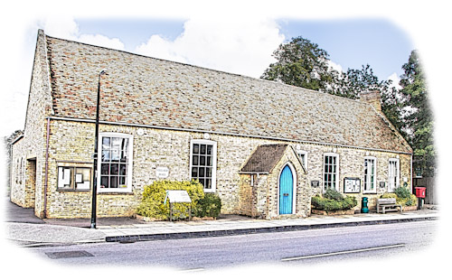
Little Downham Village Hall
Main Street,
Little Downham,
Ely
Cambridgeshire CB6 2ST

Charity Registration Number: 289116 “serving the community since 1779”

Conditions of Hire
Full payment must be paid at the time of booking, unless agreed with the Trustees. If you may need to cancel your booking you would need to give at least twenty-one days’ notice in writing to request a refund. The hall reserves its right to withhold payments if expenses have already been accrued.
Little Downham Village Hall is fully licensed bar which can be opened on request and fully stocked. If there is anything in particular you would like in the bar, we will do our best to accommodate your request. The trustees request that you do not bring your own drinks into events. All profits from bar go back into the Village Hall Charity for the upkeep and maintenance of this historic listed building. Under-age drinking is not the responsibility of the Village Hall Trustees.

The Trustees Reserves the right by notice to the hirers to terminate the rental at any time and to return the deposit. But the Trustees shall not be liable to the hirers for any loss or damage that may occur due to the results of such termination.
The hirer shall repay the Village Hall on demand the cost of reinstating, replacing or repairing any parts of the property, including furniture and fittings which are damaged, destroyed, stolen or removed as a result of negligence of the hirer during the period of rental.
The hirer is responsible for leaving the hall in a clean condition, otherwise a cleaning charge may be added, unless a voluntary charge has been paid.
The hirer must ensure that no obstructions are placed in gangways or in exits.
Fire appliances will be inspected from time to time and must be kept in their proper places and used for no other purpose.
All electrical appliances brought in by hirers must be safe to use and have a currant test certificate.
The heating is switched on remotely prior to the commencement of the hiring period, contact the booking secretary to change the settings.
Highly flammable substances shall not be brought into or used within the premises, nor shall any internal decorations of a consumable nature (e.g polystyrene, cotton wool) be erected without the consent of the Village Hall Trustees.
Nothing shall be done that will endanger the safety of people in the Hall or render invalid the policies of insurance to the Hall.
All animals brought into the hall must be always kept under control.
No nails or fastening of any kind shall be driven or put into the ceilings, any walls, partition pillar or furniture.
A car park is at provided at the back of the Hall and all cars parked there are at owner’s own risk. The hall dose not accept any responsibility to any loss or damage that may occur. When using the car park please be respectful to the neighbours and other cars when entering and leaving.
The Trustees does not accept any responsibility and shall not be under any liability for any loss from electrical power failures of any kind.
The Village Hall Trustees will not take any responsibility for any fines issued if any person is found smoking inside the hall.
The hirer shall indemnify the trustees against all claims, demands, actions or proceedings in respect of loss, damage or injury caused of or to any person which shell occur whilst such a person is in or upon part of the property.
Trustees reserve unto themselves right of entry to every part of the premises at any time.
The Fire Brigade shall be called to any outbreak of a fire, however slight and all details must be given to the booking secretary.
If an Ambulance is called again the details must be given to the booking secretary.
Please be considerate to other hirers of the hall, the hall must be left clean and tidy after the period of hire.

Booking Secretary: Amber Collins 07411205285
Email ldvhbooking@gmail.com

Little Downham Village Hall
Main Street,
Little Downham,
Ely
Cambridgeshire CB6 2ST

Charity Registration Number: 289116 “serving the community since 1779”

Booking Form

I have read the Conditions of hire and accept these conditions.
I confirm that I am over 18 years of age.

Signature…………………………………… Date……………………
Date of event……………………….
Time of Hire, From…………………. Until…………………
Note….. you are offered half an hour either side of your booking for free for setting up and clearing away.

Name Organisation

Address

Contact number Email

Type of event Wedding, Adult party, Childrens party, Christening,
Funeral, Training, Other…………………………………..

Do you require the bar for your event? YES NO
Do you require the Kitchen for your event? YES NO

