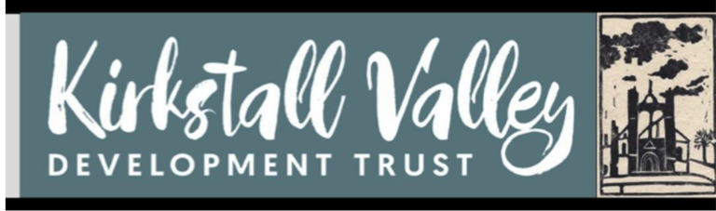
KVDT – FARM HIRING AGREEMENT TERMS AND CONDITIONS
The purpose of this agreement is to ensure all parties making bookings have clarity regarding booking arrangements and receive best possible provisions and environment.
Short term booking fees are paid at the time of booking but will be reimbursed in the event of a cancellation.
Long term bookings fees are paid in advance, on the first day of each month of hire and booking shall be no longer than one year ahead.
Hire fees are reviewed annually by KVDT.
Terms and Conditions of Hire
What you can expect from us:

- All space users to be treated with respect.
- A friendly and professional welcome.
- Commitment from KVDT staff to providing the best quality provision and environment for those using the Farm.
- The space available ready for use on the times specified by yourself
.
What we expect from you:
- If hirers contract with entertainers or other outside entertainment, they are to ensure the entertainers provide public liability insurance as the KVDT insurance policy does not cover this.
- Hirers are responsible for the Health and Safety of the people using the farm during times of the hire agreement and for loss, damage or injury to person/property, on the farm. Hirers can request a copy of KVDT Farm General Risk Assessment but are responsible for risk assessing their own event/activity.
- The number of people using the space booked is limited to the number specified in the agreement.
- Hirers are not to make any alterations to the farm, remove or dispose of any structures belonging to KVDT and are responsible for the cost of carrying out any repairs/damage incurred.
- Hirers are to make sure the farm is left in a clean, tidy condition and to ensure they take away their rubbish as no refuse collection is available.
- Hirers to be respectful of crops and wildlife
- No fires permitted on the farm
- It is not permitted to sell alcohol on the premises by cash, entry ticket or donation.
- Noise to be kept to a reasonable level as the hub is situated within a residential area and multiple office units.
- All events must end no later than time indicated in the agreement.
- Animals are not allowed on the premises, with the exception of guide or assistance dogs.
- Before an event, hirers to familiarise themselves with the fire extinguishers and how to summon emergency services.
- The hirer not to use the farm for any purpose other than that specified on the hire agreement.
- Hirers to notify KVDT of cancellation and if activity/event to be cancelled, the hirer is to notify their group

Safeguarding
In signing this agreement, all hirers who hire the premises for any event at which there are children, young people and adults at risk, agree to take full responsibility for their welfare during the event. Children under 18 years old using the farm must be supervised at all times by at least two adults.
Continuation of an event/course
Continuation of an event/course is subject to review. The agreement may be terminated by either party. KVDT reserves the right to terminate the agreement with immediate effect, where hirers do not adhere to the agreement terms and conditions.

  - KVDT reserves the right to decline any booking request.
  - KVDT reserves the right to cancel a booking under exceptional circumstances, in which case notice will be given at least XX days in advance. In such a circumstance KVDT will reimburse the hirer and any additional costs incurred by the hirer will be borne solely by the hirer.
  - In case of an emergency please contact the following: CEO Adele Rae on 07900 986570

Many thanks for booking with Kirkstall Valley Development Trust. We look forward to welcoming you.

