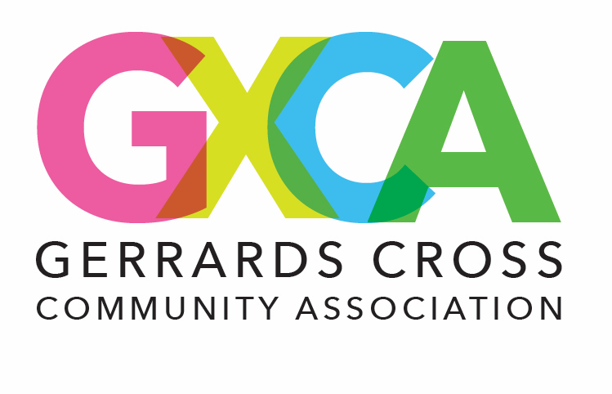
GXCA SNOOKER CLUB
Membership Directory Consent Clause
By signing below, I consent to the inclusion of my name, contact information, and other relevant membership details in the GXCA Snooker Club Membership Directory. I understand that this directory is intended for use by members only and will not be shared publicly without my further consent. I acknowledge that I may request to update or remove my information at any time by contacting office@gxca.org.uk.

Signature: ______________________
Name (Printed): __________________
Date: ___________________________

I additionally agree to my phone number being used in the WhatsApp GXCA Snooker Group. I acknowledge that I may request to update or remove my information at any time by contacting office@gxca.org.uk.

Signature: ______________________
Name (Printed): __________________
Date: ___________________________

