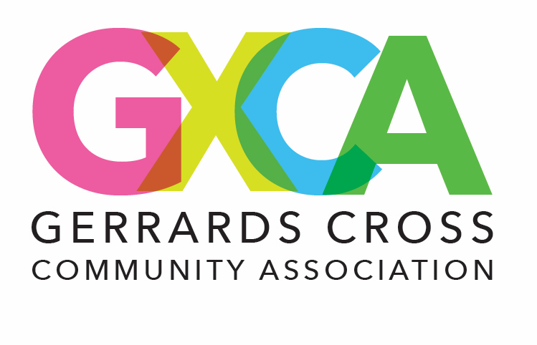
GXCA Snooker Club

Terms and Conditions of Membership
Effective Date: 1st October 2025
Location: The Memorial Centre, 8 East Common, Gerrards Cross, SL9 7AD
Contact: office@gxca.org.uk / 01753 883759

1. Membership Eligibility
1.1. All members must be at least 18 years old, unless otherwise stated.
1.2. Proof of age and identification may be required.
1.3. The management reserves the right to refuse membership or entry without providing a reason.
1.4. All members must also be a valid member of the Gerrards Cross Community Association.

2. Membership Types and Fees
2.1. Membership categories include:
- Full Membership
2.2. All membership fees are payable in advance and are non-refundable.
2.3. The club may revise membership fees with 30 days’ notice.

3. Club Rules
3.1. Members must respect all equipment, facilities, staff, and fellow members.
3.2. Appropriate dress and footwear must be worn at all times.
3.3. Alcohol and food are only permitted in designated areas.
3.4. Smoking and vaping are not permitted inside the club.
3.5. Members are responsible for any damage caused by themselves or their guests.
3.6. Any form of gambling, betting, or unsanctioned tournaments is prohibited unless authorized by management.

4. Table Booking and Use
4.1. Tables must be booked in advance or through a club-approved method.
4.2. Time slots are limited to ensure fair use.
4.3. Players must vacate tables promptly when their session ends.
4.4. Misuse of tables, cues, or equipment may result in suspension or charges.

5. Code of Conduct
5.1. Disrespectful, aggressive, or abusive behaviour will not be tolerated.
5.2. Members must follow instructions from staff at all times.
5.3. The club reserves the right to suspend or terminate membership due to breach of conduct.

6. Guests
6.1. Members may bring guests, subject to club approval.
6.2. Members are responsible for the behaviour and safety of their guests.
6.3. Guests must sign in and follow all club rules.

7. Liability and Safety
7.1. Members use the facilities at their own risk.
7.2. The club is not liable for personal injury, loss, or damage to belongings.
7.3. Any accidents or incidents must be reported immediately to staff.

8. Photography and Promotion
8.1. The club may occasionally take photos or videos during events for promotional purposes.
8.2. By entering the premises, you consent to the use of such media unless you opt out in writing.

9. Suspension or Termination
9.1. The club reserves the right to suspend or terminate a membership for:
- Breach of terms
- Non-payment
- Misconduct
9.2. No refunds will be issued in the case of termination due to a breach of these terms.

10. Amendments
10.1. These Terms and Conditions may be amended from time to time.
10.2. Members will be notified of changes via email or club notice board.

11. Governing Law
These Terms shall be governed by and interpreted in accordance with the laws of the United Kingdom.

By signing up for membership or using the club’s facilities, you agree to comply with all of the above Terms and Conditions.

