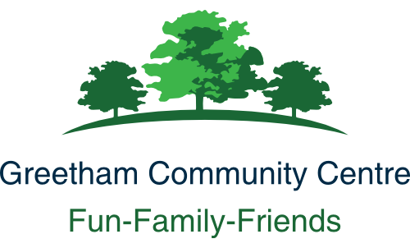
Greetham Community Centre
Conditions of Hire

We want your event to be successful. The Conditions of Hire are intended to protect all users of the Community Centre. Please take time to read them, confirm your acceptance of them.
- Fire safety. Please see the notice board. A maximum of 280 people are permitted in the Centre at any one time.
- Wifi is provided free. Please observe the conditions of use.
- You are entrusted not to cause any damage or alteration to the Centre, its fittings or the outside area and to leave it clean and tidy.
- Accidents and damage. Please report all accidents or damage to the Centre Manager as soon as possible.
- Legal requirements for your event must be followed. For example, if your activity involves children or vulnerable adults, ensure you are compliant with any necessary safeguarding measures.
- Bouncy castles are permitted only if suitably insured. A copy of the policy must be shown on request.
- Games with hard balls, such as football, cricket, or rounders, which might damage the walls or ceiling, are not permitted.
- Only alcohol purchased from the Community Centre may be consumed on site.
- Please respect our neighbours and avoid any unnecessary disturbance.
- Fireworks of any description are not permitted.
- Insurance and Cancellation – see below.

Insurance and indemnity
(i) You are liable for:
(a) costs arising from accidental and malicious loss or damage and for loss or damage arising out of your negligence to any part of the premises including its curtilage or its contents
(b) costs arising from accidental and malicious loss or damage and for loss or damage
arising out of your negligence done to our WiFi service (if any)
(c) all claims, losses, damages, and costs made against or incurred by us, our employees, volunteers, agents or invitees in respect of damage or loss of property or injury to persons arising as a result of your use of the premises (including the storage of equipment) and your use of our WiFi service (if any), and
(d) all claims, losses, damages and costs made against or incurred by us as a result
of any nuisance caused to a third party as a result of your use of the premises
and/or the use of our WiFi service (if any), and subject to sub-clause (ii), you
must indemnify us against such liabilities.
(ii) We will take out adequate insurance to insure the liabilities described in sub- clauses (i)(a) and (b) above and may, in our discretion and in the case of non- commercial hirers, insure the liabilities described in sub-clauses (i)(c) and (d)above. We will claim on our insurance for any liability you incur but you must indemnify us against:
(a) any insurance excess incurred and
(b) the difference between the amount of the liability and the monies we receive
under the insurance policy.
(iii) Where we do not insure the liabilities described in sub-clauses (i)(c) and (d)
above, you must take out adequate insurance to insure such liability and on
demand must produce the policy and current receipt or other evidence of cover to
our Hall Secretary. If you fail to produce such policy and evidence of cover, we
will cancel this Agreement and re-hire the premises to another hirer.
We are insured against any claims arising out of our own negligence.

Cancellation
If you wish to cancel the booking before the date of the event and we are unable to conclude a replacement booking, we may, in our complete discretion, return the deposit or require payment of the hire fee.
We reserve the right to cancel this Agreement by giving you written notice in the event of:
- the premises being required for use as a Polling Station for a Parliamentary or Local Government election or by-election;
- our reasonably considering that (a) such hiring will lead to a breach of licensing conditions, if applicable, or other legal or statutory requirements, or (b) unlawful or unsuitable activities will take place at the premises as a result of this hiring;
- the premises becoming unfit for your intended use;
- an emergency requiring use of the premises as a shelter for the victims of flooding, snowstorm, fire, explosion or those at risk of these or similar disasters.
In any such case you will be entitled to a refund of any deposit already paid, but we will not be liable to you for any resulting direct or indirect loss or damages whatsoever.

