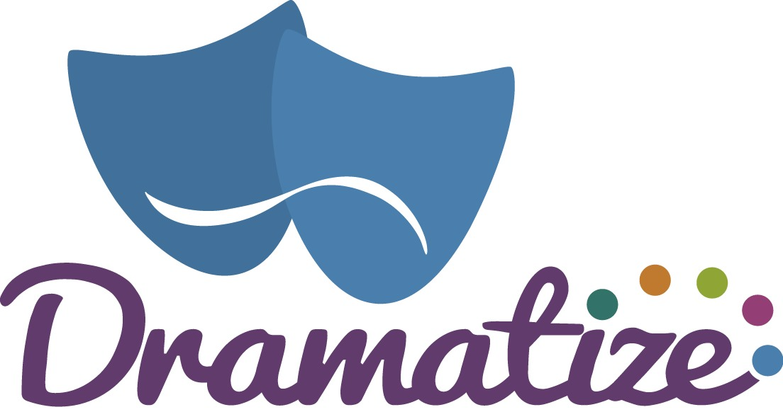
Pricing Policy for the Community Centre
Introduction

The Community Centre is committed to providing accessible and affordable services to all members of our community. Our pricing policy is designed to ensure transparency, fairness, and inclusivity, while also maintaining the financial sustainability of our centre.

Objectives
- Affordability: Ensure that our services are affordable to the widest range of community members.
- Transparency: Provide clear and understandable pricing information for all services offered.
- Inclusivity: Offer pricing options that cater to diverse economic backgrounds.

Pricing Structure

Our main hall space:

Charged at £35 per hour for one-off bookings

£25 for regular bookings (6 or more sessions)

Our side hall space:

Charged at £25 per hour for one-off bookings

£18 for regular bookings (6 or more sessions)

No discounts are made to charities as Dramatize is also a charity and not-for-profit.

Payment Options
- Payment Methods
  - We accept cash, credit, and debit card payments.
  - Online payment options are available through our website.

Payments have to be made in full to secure the bookings.

Review and Updates
This pricing policy is reviewed annually to ensure it meets the needs of our community and the operational requirements of the centre. Updates will be communicated through our website and comms.
For any inquiries or further information regarding our pricing policy, please contact our administration office. We are here to support you and ensure you have the best possible experience at our Community Centre.

