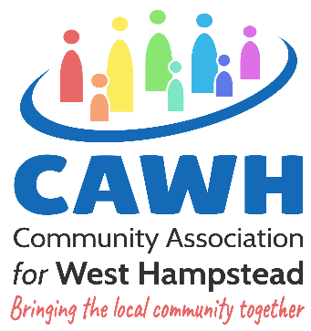Membership Form
17 Dornfell Street, London NW6 1QN
Tel: 020 7794 3729
www.cawh.org.uk Email: info@cawh.org.uk

We encourage and welcome our users and those who live and work in West Hampstead to become members. It is an easy way to demonstrate support for the Association. In addition to regular information about CAWH activities and events, you will receive invitations to meetings relevant to the Association, including the AGM. Members (18+) are entitled to vote at the AGM and are eligible to become Committee members, contributing to the future direction of CAWH. The information provided on this form will only be used for the purposes above and will not be shared with third parties.

Membership is currently free and if you decide to cancel your membership you just need to tell us.

Personal Details
Full Name: |  |  | DOB: / /
Address:
Telephone: |  | Mobile:
Email address: |  | Website:

Interests (please select all that apply)
60 +  | CHILDREN/FAMILIES/HOLIDAY activities 
VOLUNTEERING  | OTHER ACTIVITIES/ONE-OFF EVENTS 

Declaration
I agree to become a member of the Community Association for West Hampstead. Should the company have to close, I promise to pay £1 (one pound) towards its debts if asked to do so.

Signature ____________________________________ Date _____________________

General Data Protection Regulation (GDPR): The personal information that you provide on this form shall be only used for the purposes of membership and will not be shared with any third-party organisation/person outside Community Association for West Hampstead

Consent to receive information and newsletters about CAWH activities (please tick)
You must give us consent by ticking the box below so that we can inform you of our activities.

I consent to CAWH sending me information and newsletters about its activities and events:

