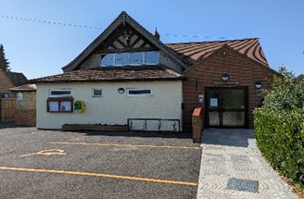
Colne Village Hall Privacy Policy Registered Charity number: 278191

Registered address: Colne Village Hall, East Street, Colne,
Huntingdon, Cambridgeshire. PE28 3LZ
What information do we collect?
When you contact us via email, writing, by phone or in person, you may provide us with personal information regarding you. This may include:
- your full name and title, date of birth
- postal address, email address and phone number
- We may collect and hold information about the contact you have with us as: a service user, audience member, performer, donor or supporter of Colne Village Hall, and may include details of:
- event attendance, performances or workshops
- contact preferences
- payment details where applicable
- details of correspondence sent to you, or received from you
- donor status
- interests and activities
- any other information provided by you at the request of the Trustees
When we ask you to provide personal information, we will let you know why we are asking, and how we will use your data, by directing you towards this notice.
How do we use this information?
We use this information to improve the service we give you, record-keeping, to provide you with information, or services that you request, or which we feel may interest you, and to notify you about changes to our services:
For example: To send you promotional, marketing or fundraising information by electronic communications, telephone or post. These can include:
- Information on events or activities provided by or related to Colne Village Hall.
- News and updates about Colne Village Hall.
- Other relevant communications based upon your relationship with Colne Village Hall.
How do we protect your personal information?
We understand that your personal information and privacy are important. We make every effort to ensure that the information you share with us is recorded accurately, retained securely and used only according to your wishes. We protect your personal information and adhere to current data protection legislation.
We do not give out, sell or trade our mailing list data with third parties
Where you have consented to the use of data you have provided us with, we may share this with relevant partners, e.g. funders, for reporting purposes only.
We may also disclose anonymous information regarding demographics and other similar information to third parties for reporting purposes only.
If at any time you no longer wish to receive communications from us, simply contact one of the Trustees:
Secretary: virginiakaren23@gmail.com, or the Booking Officer: tonysteward1@btinternet.com
Please help us to keep your information up to date by emailing the secretary or booking officer if your personal information changes, or if you wish to correct or delete it. We will endeavour to correct, update or delete information you have provided to us within 7 working days.

Date Approved 11th August 2025 Date to Review May 2026

Signed SJ Harrison Chair

