Colne Village Hall Risk Management Policy
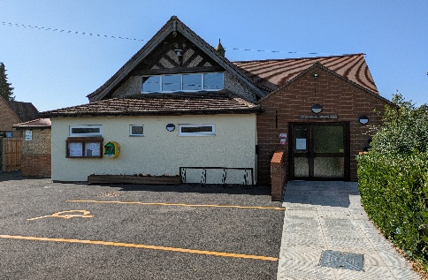

Author : David Parsons Charity Number: 278191

Introduction

The Risk Assessment is a systematic general examination of working conditions, workplace activities and environmental factors that will enable the Management Committee to identify any and all potential inherent risks. The Management Committee, based on a recorded assessment, will take all practical and necessary steps to reduce or eliminate the risks, insofar as is practically possible. This Policy is used in conjunction with the CVHMC Risk Management Scheme.
The list is not exhaustive, and the CVHMC may wish to consider other risks not identified.

Financial Management

Financial Records - Bank and Banking
- The treasurer reconciles the bank account once a month when the statement arrives. Any problems/irregularities are dealt with immediately. The CVHMC will choose replacement signatories, as required.

Reporting and Auditing
- A statement is produced regularly before each CVHMC meeting which is discussed and approved at the meeting. This statement includes, bank reconciliation, budget update (Balance Sheet), and a breakdown of receipts and payments balanced against the bank. CVHMC regularly audit internally to comply with the Fidelity Guarantee.

Grants received
- The CVHMC does not presently receive any regular grants. One off grants would come with terms and conditions to be satisfied.

Best Value Accountability
- Normal CVHMC procedure is to seek, if possible, three quotations for any substantial work to be undertaken. For major contract services, formal competitive tenders are sought. If a problem is encountered with a contract, the Secretary would investigate the situation, check the quotation/tender, research the problem and report to the CVHMC.

Salaries and associated costs
- The CVHMC authorises the appointment of all employees through its meetings. Salary rates are assessed annually by the CVHMC. Salary analysis and slips are produced monthly.

Employees and Trustees
- The requirements of the Fidelity Guarantee insurance to be adhered to with regards to Fraud. All employees to be provided with adequate direction and safety equipment, where appropriate, needed to undertake their roles.

Training for all members
- Ensure all committee members and employees are encouraged to attend training sessions.

Minutes/Agendas/Notices
- Minutes and agenda are produced in the prescribed method by the Secretary. Minutes are approved and signed at the next CVHMC meeting. Business conducted at the meetings should be managed by the Chair.

Insurance
- An annual review is undertaken of all insurance arrangements to ensure best value and that adequate cover is being achieved. Employers and Employee liability insurance is a legal requirement if your business employs one or more people. Ensure compliance measures are in place. Ensure Fidelity Guarantee and Trustees Indemnity are in place.

Data protection (GDPR)
- The CVHMC has a privacy policy, which has been issued to all hall users.

Physical Equipment or Areas

Maintenance
- All assets owned by the CVHMC are regularly reviewed, inspected and maintained as required. All repairs and relevant expenditure for any repair is actioned/authorised in accordance with the current procedures of the CVHMC. Assets are insured.

Meeting Location
- The Committee meetings are held in the Village Hall. The CVHMC consider the location to be adequate for the Committee and Public who attend from Health & Safety, Disability Discrimination and comfort aspects.

Paper records
- The CVHMC records are stored at the Secretary’s and the Treasurer’s houses, in filing cabinets. Records include historical Correspondences, the agendas, minutes and End of Year financial report. This also includes records such as personnel, insurance, salaries etc.

Electronic records
- The CVHMC electronic records are stored on the Secretary’s and the Treasurer’s computers. Back-ups of the files are taken at regular intervals and stored in the Cloud.

Village Hall
- Fire arrangements are checked quarterly. Fire extinguishers are maintained by a contractor annually. The Premises are cleaned weekly. All equipment is inspected regularly.

This policy will be reviewed annually.

Date Approved 11th August 2025 Date to Review May 2026

Signed SJ Harrison Chair

