COLDEN COMMON COMMUNITY CENTRE 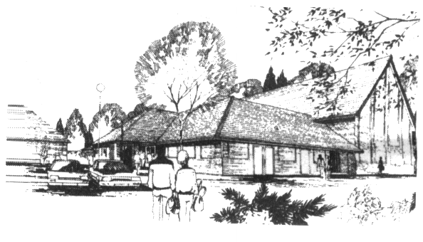 St Vigor Way, Colden Common

Winchester, S021 1UU

Hiring Rates with effect from **1st April 2025:-**

## STANDARD HIRING RATES FOR 1st April 2025 – 31st March 2026

|  |  |  |  |  |
| --- | --- | --- | --- | --- |
| **HALL** |  | **Hiring rates**  **Per hour**  **£** |  |  |
|  |  |  |  |  |
| Gloucester Hall |  | **23.25** |  |  |
|  |  |  |  |  |
| **Gloucester Hall Fri/Sat Evening rate** |  | **26.25** |  |  |
|  |  |  |  |  |
| **Gloucester Hall Fri/Sat Evenings, excess hrs** |  | **36.75** |  |  |
|  |  |  |  |  |
| **Stage** |  | **+ 10%** |  |  |
|  |  |  |  |  |
| **Patrick Moore Room** |  | **18.25** |  |  |
|  |  |  |  |  |
| **Bert Stratton Lounge**  **Jenny Gray Room** |  | **13.65**  **10.50** |  |  |
|  |  |  |  |  |
| **Kitchen** |  | **+ 10%** |  |  |
|  |  |  |  |  |
| **Kitchen – large or catered events** |  | **25.00**  **Per event** |  |  |
|  |  |  |  |  |
| **Whole Complex** |  | **65.75** |  |  |
|  |  |  |  |  |
| Whole Complex **Per week-end day** |  | **995.00** |  |  |

**EXTRAS - £25 DEPOSIT REQUIRED FOR ALL**

Television & video, PA system, Mobile sound system

£15.00 for all bookings, 10% of hiring fee for regular hirers

Please return this slip to confirm receipt of the 2025/2026 hiring rates.

Name:………………………………………………………………….

Group:………………………………………………………………….

Day/Time of booking:…………………………………………………

Colden Common Community Centre is supported by Hampshire County Council, Winchester City Council and Hampshire Police Authority

The Colden Common Community Association is a UK Registered Charity No 292438