COLDEN COMMON COMMUNITY ASSOCIATION

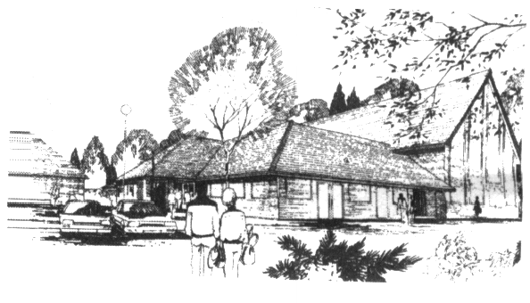

**Registered Charity No 292438**

St Vigor Way, Colden Common

Winchester, S021 1UU

**DATA PROTECTION POLICY**

Data is defined as information about living individuals, which can be used to identify that person whether by amalgamation with other information or not. Sensitive data includes details about ethnicity, religion, health, sex life or criminal record.

Our data protection policy sets out our commitment to protecting personal data, and how that commitment is implemented. CCCA practice is to meet both the spirit and letter of the relevant legislation.

# COMMITMENT

We are committed to:

1. ensuring compliance with the data protection principles, as listed below
2. meeting the legal obligations of the [Data Protection Act 1998](http://www.opsi.gov.uk/Acts/Acts1998/ukpga_19980029_en_1) and General Data Protection Regulations
3. ensuring that data is collected with freely given consent and used fairly and lawfully
4. processing personal data only in order to meet legitimate interests. operational requirements or fulfill legal requirements
5. taking steps to ensure that personal data is up to date and accurate
6. establishing appropriate retention periods for personal data
7. ensuring that data subjects' rights can be appropriately exercised, including withdrawal of consent, “right to be forgotten”, correction, or prompt handling of Data Subject Access Requests
8. providing appropriate security measures to protect personal data
9. ensuring that a nominated trustee is responsible for data protection compliance and provides a point of contact for all data protection issues (Hazel Crosthwaite)
10. ensuring that all Colden Common Community Association trustees, staff and volunteers are made aware of good practice in data protection
11. providing adequate training for all staff/volunteers responsible for personal data
12. ensuring that everyone handling personal data knows where to find further guidance
13. ensuring that queries about data protection, internal and external to the organisation, are dealt with effectively and promptly
14. regularly reviewing data protection policy and procedures

# DATA PROTECTION PRINCIPLES

Personal data shall be

1. processed fairly and lawfully;
2. obtained for one or more specified and lawful purposes, and not further processed in any manner incompatible with any purposes
3. adequate, relevant and not excessive in relation to the purpose or purposes for which they are processed
4. accurate and, where necessary, kept up to date
5. not be kept for longer than is necessary for that purpose
6. not divulged to any third parties unless required by law
7. Personal data shall be processed in accordance with the rights of data subjects under the Data Protection Act 1998 by the data protection trustee
8. Appropriate precautions shall be taken against unauthorised and unlawful processing of personal data and against accidental loss or destruction of, or damage to, personal data
9. Personal data shall not be transferred to a country or territory outside the European Economic Area unless that country or territory ensures an adequate level of protection for the rights and freedoms of data subjects in relation to the processing of personal data, and a specific contract is in place with that provider;
10. Any breaches are reported within 72 hours to the Information Commissioner’s Office

<https://ico.org.uk/for-organisations>

Signed Hazel Crosthwaite

Data Protection Trustee September 2025