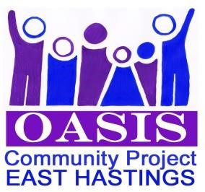 **Oasis Community Project – East Hastings**

**Membership / Mailing list Form 2024 / 2025**

**Charitable Incorporated Organisation number: 1161078**

Membership of Oasis Community Project – East Hastings is open to individuals aged over 18 years within Hastings and St Leonards, with our main area of benefit being East Hastings. The Oasis Trustees consists of residents who live in the area and make decisions on the Charity.

**All memberships start from June and cannot be transferred to others.**

**Being a paid member entitles you to reduced price on activities and outings**

The membership runs from **1st June 2024 to 31st May 2025** (we will be flexible as depends on our AGM date)

**Annual cost - £19 per adult & £9.50 per child**

**You can just be on our mailing list for FREE but will not receive subsidies on outings & activities.**

Name / s…………………………………………………………………………………………………………………………………………………………………

Phone number (home & mobile) …………………………………….........................................................................................

Address ……………………………………………………………………………………. Postcode ……………………………………………..........

Email address:……………………………………………………… Years of birth ..........................................................................

**Which list ?** Over 50’s………. Families ……………. Inbetweenies* ..............

* (Do not have children, or do not have children under 18 years but are not old enough for over 50’s!)

I / We apply to become a member of Oasis Community Project. I agree that my details can be kept in computerised and paper form ......... **Please tick**. We may ask if you mind having your photo taken to be used on our Facebook, website, leaflet or poster for publicity. We will ask you to agree before we publish any photos of you or your family. I am **ok / not ok** with you using photos of me / us * Please delete which is appropriate for you

I / we agree to be bound by Oasis Community Project –East Hastings constitution and policies (available copies on request) ................... **Please tick**

**I / we only wish to be on the FREE mailing list ........... please tick**

**Payments may be made by cheque, cash or bank transfer at £19 each adult & £9.50 per child.**

**I enclose £………….......... CSH / CQ / bank transfer (Pls circle) Date …………………… Signed ………………………….....**

**Cheques made payable to: Oasis Community Project – East Hastings**

**Please bring to the community Centre or send to:**

**Jackie Gaunt, Oasis Community Hub & Development Manager, Oasis Community Project,**

**Broomgrove Community Centre, 85 Chiltern Drive, Hastings, East Sussex TN34 3PY.**

Office: 01424 *427 582*  Mobile: 07927 905029

E.mail: *Oasis@orevalley.co.uk* Website: www.orevalley.co.uk

Facebook: Oasis Community Project updated 31.5.24