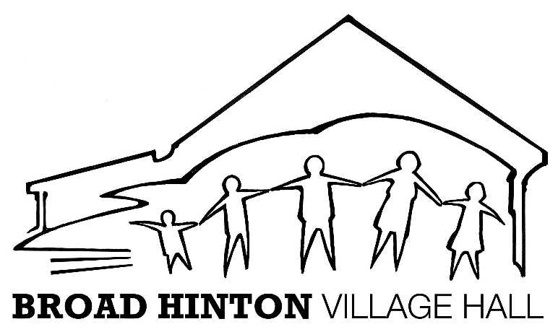
Refundable Deposit Request & Approval Form
First Draft | 11th December 2023
Amended | 23rd December 2023
Amended | 26th January 2024
Amended

Name of Hirer
Date of Event
Refund Paid £

Have the conditions for payment been met in full?
Tick/cross
- The hiring was concluded in line with the booking made and in accordance with T&Cs
- The Departing Checklist has been fully completed.
- No reported noise, car parking or nuisance issues from surrounding neighbours/village.
- No resident complaints received in the last 7 days since the event concluded.

Refund Deductions:
Cleaning | £
Damage repairs/replacements | £
T&C Fine? | £
Extra Hours of Hire | £
Extra equipment used | £

Net Refund now payable | £
Date Refund payable
(7 days after event)
Other

Authorised by the Trustee Committee Member
Name |  | Date
Signed by

Instructions to the BHVH Treasurer.

Please refund the hirer’s deposit of £: net

Bank Details for Return of refundable deposit
Bank/Sort Code/Account

